HOMEOSTASIS, EXCRETION, OSMOREGULATION
Definitions of terms:
Homeostasis: This is the maintenance of a constant internal environment within narrow range suitable for normal body functioning.
Examples:
-Concentration of blood glucose at 90mg/100cm³, -Average core body temperature at 37⁰C (98.6⁰F)
-Blood PH (acid-base balance) at 7.4, -Blood pressure, -Concentration of carbon dioxide.

Excretion
Removal of metabolic waste products from the body. Examples of waster products; CO₂, urea, uric acid, ammonia, excess water, excess mineral salts, bile pigments, oxygen (plants) etc.

Osmoregulation
Maintenance of constant osmotic pressure in body fluids of an organism by controlling water and salt concentrations.
Examples: Concentration of various ions e.g. Na²⁺, K⁺, Cl⁻ and water

Secretion: Production of substances useful to the body by cells.
Examples: Release of hormones, digestive juices
Egestion
The removal of undigested food from the body.
Examples: Elimination of faeces from the gut (defecation) and undigested food from the food vacuole of amoeba.

IMPORTANCE/SIGNIFICANCE OF EXCRETION
-Enables removal of unwanted by-products of metabolism.
Prevents accumulation of waster products which may become toxic to the cells.
IMPORTANCE/SIGNIFICANCE of osmoregulation
-It regulates ionic concentration of body fluids to facilitate efficiency of cell activities e.g. nervous coordination, protein synthesis, hormone production, muscle contraction, enzyme activity etc.
-It regulates the water content of body fluids.
-Enables regulation of ions that have a major influence on PH of body fluids e.g. H⁺ and HCO₃⁻
-Enables removal of excess nutrients that are taken in that if allowed to accumulate would interfere with cell activities.
-Gives increased environmental independence
THE DIFFERENT ENVIRONMENTS AND THEIR PROBLEMS
Environment | problems faced by organisms
Sea water:  highly saline environment | Problems: (1) Excessive osmotic water loss (2) Excessive salt gain by diffusion  solution: active pumping of salts out of the body through specialized cells.
Fresh water: low saline environment | Problems: (1) excessive osmotic water gain (2) excessive salt loss by diffusion  solution: active pumping of salts into the body through specialized cells.
Brackish water: moderate saline environment, it includes estuarine water and intertidal zones. | Problems: variable salinity
Terrestrial environment | This land environment. Problems: Water loss by evaporation

EXCRETION IN PLANTS
The following account for the absence of complex/elaborate excretory systems in plants as those in animals:
(1) Toxic wastes do not accumulate because they are utilized by the plant e.g. CO₂ and water are raw materials for photosynthesis while oxygen participates in respiration
(2) Extra gaseous wastes are removed from plant bodies by simple diffusion through the stomata and lenticels
(3) Most of the organic waste substances formed in plants are non harmful and can be stored in the plant tissues which are removed periodically e.g. leaves and bark
(4) Some plants store other wastes such as resins in organs that later fall off e.g. leaves
(5) Excess water and dissolved gases are removed by transpiration through the stomata
(6) Some plants remove waste products by exudation e.g. gums, resins, latex and rubber
(7) In some plants, guttation occurs i.e. excess water with dissolved salts ooze out through hydathodes at leaf surfaces
(8) Organic acids which would be harmful to plants often combine with excess cations and precipitate as insoluble crystals which can be safely stored in plant cells. E.g. excess Ca²⁺ combines with oxalic and pectic acids to form the non-toxic calcium oxalate and calcium pectate
(9) Plants synthesize all their Organic requirements according to demand, leaving no excess of protein hence very little excretion of nitrogenous waste substances occurs
(10) The rate and amount of catabolism is much slower and much less than that of animals of similar weight, and as a result the waste products accumulate more slowly.

Excretory products in plants
- Carbon dioxide, Water and Oxygen from respiration and photosynthesis respectively.
- Anthocyanins stored in petals, leaves, fruits, barks.
- Tannins deposited in dead tree tissues like wood and barks
- Calcium oxalates, calcium carbonates and Latex (rubber)
- Alkaloids like quinine, cannabis, cocaine, caffeine, morphine etc.

OSMOREGULATION IN PLANTS:
Depending on how much water is available in their natural environment, plants can be categorized into the following groups:
a) Hydrophytes: plants living completely or partially submerged in fresh water. They have water in plenty and therefore there is no problem of obtaining it e.g. water lilies, water hyacinth, water lettuce, etc.
b) Mesophytes: plants inhabiting normal well-watered soils.
c) Xerophytes: plants inhabiting dry areas e.g. desert.
d) Halophytes: plants inhabiting areas of high salinity e.g. estuaries, salt marshes. The Australian saltbush (Atriplex spongiosa) excretes excess salts by actively depositing the salt in special epidermal bladder cells, which eventually fall off or burst.

Adaptations of xerophytes for surviving unfavourable water balance (more loss than uptake from soil).
Structural adaptations | Physiological adaptations
- Possession of extremely deep roots so as to obtain water from deep down below the water table e.g. acacia and Oleander.  - Shallow root system for absorbing moisture even after slight showering e.g. cactus  - Possession of fleshy succulent stems and leaves that store water in large parenchyma cells e.g. bryophylum and cactus.  - Reduction in stomata number to reduce on transpiration.  - Possession of sunken stomata, hairy leaf surface to trap air and reduce on transpiration.  - Rolling / curling / folding of leaves to reduce Transpiration e.g. marram grass (Ammophila)  - Hairy epidermis for reflecting solar radiation and trapping humid air next to leaf surface and reduce transpiration.  - Possession of thick cuticle, which is impermeable to water e.g. prickly pear (Opuntia).  - Reduction of surface area over which transpiration has to occur by having small leaves. | - Reversal of the normal stomatal rhythm in some plants e.g. opening stomata at night and closing during day time so as to reduce on water evaporation.  - Increased levels of abscisic acid, which induces stomatal closure so as to reduce water loss.  - Possession of tissues tolerant to desiccation e.g. low solute potential of cytoplasm and production of resistant enzymes.  - Leaf fall in deciduous trees so as to cut down transpiration  - Survival of drought as seeds or spores that are highly dehydrated and protected within a hard coat

Note: Other than unfavourable water balance, terrestrial plants are faced with other challenges that result from environmental variables like temperature, ionic concentrations (nutrients), water/ moisture, light, wind/air currents. Accordingly, plants have developed mechanisms that enable successful reproduction, gaseous exchange, nutrition, propagation (dispersal), support, loss of excess water and salts etc.

HOMEOSTATIC FEEDBACK SYSTEMS
Process | Definition / Explanation | Examples / Comments
Feedback system | A mechanism in which an input stimulus causes an output response that ‘feeds back’ to the initial input
a) Negative feedback | A mechanism in which the effect of deviation from the normal condition triggers a response that eliminates its deviation in order to reduce further corrective action of the control system once the set point value has been reached. | In negative feedback mechanism, a stimulus causes a sensory receptor to signal a regulatory centre in the brain. The regulatory centre then signals an effector to respond and the response cancels / reverses / negates the stimulus to restore the condition to the norm.
b) Positive feed back | A mechanism in which the effect of deviation from the normal condition intensifies the original response such that the change tends to proceed in the same direction as the initial stimulus. | Examples of positive feed back include:  -A 10⁰C in temperature doubles metabolic activity, releasing more heat that raises the activity even more.  -During blood clotting to stop bleeding to keep blood volume constant, one clotting factor activates another in a cascade that leads quickly to the formation of a clot.  -During childbirth, oxytocin release stimulates contraction of uterus muscles, which in turn stimulates further oxytocin release until the foetus is expelled.  -Subsequent depolarisation of the neurone membrane after the initial stimulus.
Cascade effect: The way in which a small amount of say hormone can cause a target organ to produce a large amount of product.

Qn: Explain why positive feedback mechanisms are few in biological systems
It is because positive feedback mechanisms cause larger deviations from the normal set point which may lead to extreme conditions and death of the organism.

CHARACTERISTICS OF EFFICIENT HOMEOSTATIC SYSTEM

Components | Explanation of the role of components
Receptors / detectors | Should be able to detect even small deviations from the norm / reference point so as to initiate corrective mechanisms.
Control centre | Should be able to coordinates information received from various receptors at the same time and sends out instructions which will correct the deviation.
Effectors /  responding organs | Should:  (i) Avoid allowing large variations to occur because they can damage the body tissues (see y in the graph below).  (ii) Work very fast to effect the necessary changes needed to return the system to the reference point / norm (see x in the graph below).
Reference point / norm | Should be optimum for the body’s metabolic functioning.
Feedback loop | Hormones and or nerve impulses that inform the receptor of any change in the system as a result of the action by the effectors

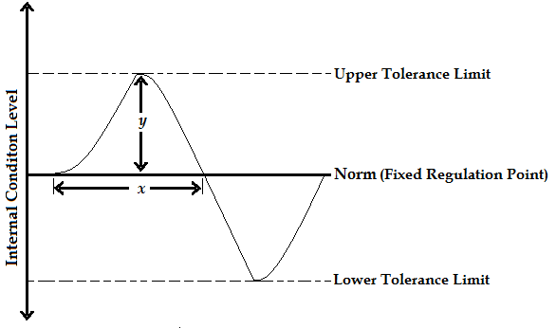

NOTE:
A good homeostatic system should allow only small changes in x and y as indicated on the graph above.

TISSUE FLUID / EXTRACELLULAR FLUID / INTERCELLULAR FLUID
This is the fluid found about tissue cells containing molecules that enter from or exit to the capillaries. The body’s internal environment consists of tissue fluid and blood that bathe the cells.

HOW TISSUE FLUID IS FORMED
This is by the process of ultrafiltration i.e. Hydrostatic pressure of blood forces small molecules to exit blood capillaries via fine pores on the basement membrane but large molecules are held back.
- Fluid movement in and out of capillaries depends on the balance between the blood pressure (hydrostatic pressure) and osmotic pressure (solute potential).
- Osmotic pressure is created by the presence of salts and plasma proteins in blood while blood pressure is created by the pumping action of the heart and the resistance to blood flow caused by the small size of capillaries.
- At the arterial end of a capillary bed, blood pressure is higher than osmotic pressure of blood. This results in forced exit of small molecules like glucose, water, amino acids, ions, oxygen, and small plasma protein molecules via fine pores on the basement membrane of arterioles but large plasma protein molecules, red blood cells are retained.
- Midway along the capillary bed where the blood pressure is lower, the two forces of blood pressure and osmotic pressure essentially cancel each other and the substances diffuse according to their concentration gradients i.e. glucose, oxygen and other solutes diffuse out of the capillary while carbon dioxide and other wastes diffuse into the capillary. No net movement of water occurs.
- At the venule end of a capillary bed, blood pressure is lower than osmotic pressure of blood, resulting into entry of water, carbon dioxide, wastes and solutes into the capillaries.
- However, the total amount of fluid exiting capillaries at the arterial end exceeds that entering at the venule end. This is because the osmotic pressure causing entry of fluid at the venule end is lower than the blood pressure causing exit of fluid at the arterial end, resulting into failure of some fluid flowing in capillaries, forming what is called tissue fluid.

Note: Tissue fluid is drained by the lymphatic system, where it becomes lymph which eventually passes into veins at the same rate as it is formed, failure of which results in a condition known as oedema
(Illustration 1Michael Roberts & Reiss, etal: Advanced Biology, 1st ed. 2000 Page 268)
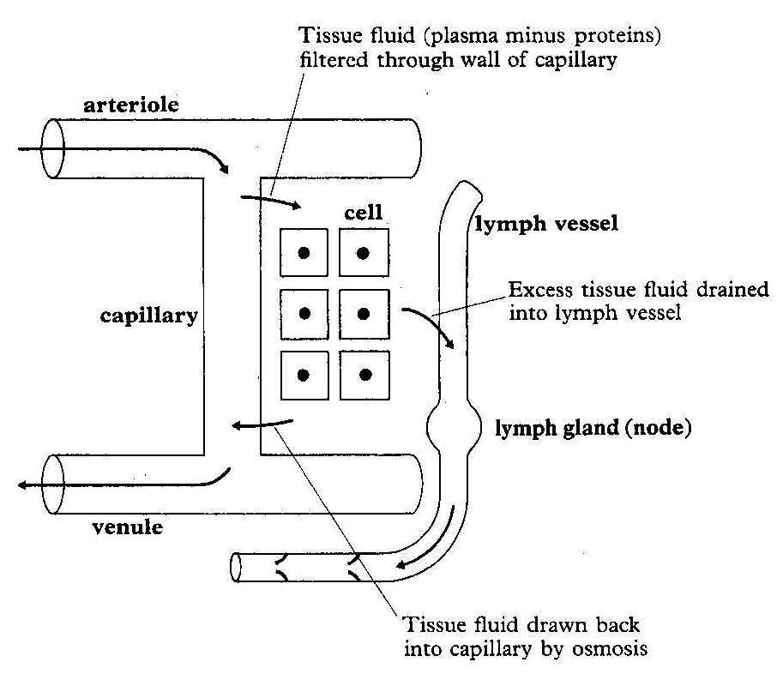

Q. Describe how unicellular organisms and cells of multicellular organisms control their internal environment
- At cellular level, the internal environment of a cell is its cytoplasm; while the cell’s immediate surrounding constitutes the external environment.
- Tissue fluid in most animals and sap in plants constitute the external environment of cells of multicellular animals and plants respectively, but form internal environments of these organisms.
- The constituents of a cell cytoplasm are modulated by the partial permeability of its cell membrane and the level of activity of its enzymes.
- The cell surface membrane selectively allows entry and exit of molecules at a strictly controlled rate by diffusion gradient, osmotic gradients, and active transport e.t.c.
- The nature and amounts of materials synthesized by cells is controlled by rates of protein synthesis and they catalyse most catabolic and anabolic reactions within cells.
- Therefore, relative constancy of the cell’s internal environment depends on supply of metabolites, utilization of cellular material or output through activity of the modulators.

OSMOREGULATION IN ANIMALS
Excretory and homeostatic organs in various animals
Animal | Excretory and homeostatic structures
Platyhelminthes e.g. planaria, liverfluke, tapeworm | Flame cells (solenocytes)
Annelids | Nephridia
Insects, millipedes | Malpighian tubules
Arachnids | Book lungs
Fish | Gills and kidneys
Amphibians | Lungs, kidneys, liver and gills
Birds and Reptiles | Lungs, kidneys and liver
Mammals | Lungs, kidneys, liver and skin
Unicellular organisms | Cell surface membrane
Crustaceans | Antennal glands
Roundworm | Excretory cell
Relationship between excretory products and habitats of some animal groups
Nature of waste | Excretory product | Habitat | Animals
Nitrogenous waste | Urea | Terrestrial | Mammal
Nitrogenous waste | Ammonia | Aquatic | Fresh water bony fish and protozoa
Nitrogenous waste | Uric acid | Terrestrial | Birds and Terrestrial insects
Nitrogenous waste | Guanine | Terrestrial | Spiders
Nitrogenous waste | Trimethylamine oxide | Aquatic | Marine bony fish
Nitrogenous waste | Creatine | Aquatic | Some marine fish
Non Nitrogenous waste | Carbon dioxide | Terrestrial | Mammals, birds and protozoa
Non Nitrogenous waste | Excess water and mineral salts | Terrestrial | Mammals, birds, reptiles
Non Nitrogenous waste | Bile salts | Terrestrial | Mammals

OSMOREGULATORY CATEGORIES OF ORGANISMS
a) Osmotic conformers (Osmo conformers): Animals whose Osmotic concentration of body fluids fluctuates according to that of the environment. E.g. fresh water lower animals.
Euryhaline animals: are those that tolerate wide variations in salt concentration of water. They usually live in brackish water
Stenohaline animals: are those with narrow tolerance to environmental variation of salt concentration in water e.g. Maia, Arenicola.
(i) Euryhaline Osmotic conformers (tissue tolerant species): species that tolerate wide external and therefore internal osmotic fluctuactions.
(ii) Stenohaline osmotic conformers: species that tolerate only limited external and therefore internal osmotic fluctuactions. Such organisms’ habitats are limited to environments of constant concentration e.g. the hagfish is strictly marine and stenohaline, its body fluids are iso-osmotic (have same concentrations as sea water)

b) Osmotic regulators (Osmo regulators): Animals that maintain or regulate within narrow limits the internal body osmolarity despite environmental changes. E.g. Most marine vertebrates, higher fresh water animals (they remain hyperosmotic)
(i) Euryhaline Osmotic regulators: species that maintain within narrow limits the internal body osmolarity over a wide range of environmental changes. E.g. migratory fish like eel (Anguilla bengalensis) which migrate from fresh wter to sea water, Salmon (Salmo fario) which migrate from sea to fresh water for spawning,
(ii) Stenohaline osmotic conformers: species that regulate the internal body osmolarity over a narrow range of external environmental changes.

INFLUENCES OF WATER AVAILABILITY ON EXCRETION OF NITROGENOUS WASTES
Note: nitrogenous wastes are produced by the breakdown of proteins, nucleic acids and excess amino acids
- Ammonia is highly toxic hence its excretion requires a lot of water for dilution. Being highly soluble and readily difusable, it is excreted by fresh water bony fish, protozoa, porifera, Cnidarians which live in abundance of water. Such animals are said to be ammoniotelic.
- Urea is relatively toxic and very soluble hence can be easily diluted before elimination, so it is excreted by some terrestrial animals like mammals and marine ones whose body fluids are hypotonic to seawater. Animals that excrete mainly urea are said to be ureotelic
- Uric acid is almost non-toxic and highly insoluble, requiring very little water for its elimination so it is excreted by animals living in very arid conditions e.g. birds, insects and reptiles, which live in water shortage. These animals are said to be uricotelic
- Trimethylamine oxide is soluble but non-toxic, requiring relatively less water for its elimination, so is excreted by marine bony fishes suffering from water shortage.
- Guanine is less soluble than uric acid and requires no water for its elimination, hence is excreted by terrestrial spiders that live in scarcity of water.

OSMOREGULATION IN SEA WATER
Animals first evolved in the sea, and most marine invertebrates are osmoconfromers.
Shore crab (Carcinus maenas) | Mitten crab (Eriocheir) | Fig. 14.11 B Roberts MBV: Biology a functional approach, 4th ed. P. 222 or Colin Clegg (1981) p.195
-Antennal glands at the base of the antennae excrete excess water and nitrogenous wastes.  - Antennal glands are incapable of holding back salts (they eliminate salts and water alike), resulting into production of urine isotonic with blood.  -Gills absorb salts from the surrounding medium and secrete them into blood against a concentration gradient so as to maintain an internal osmotic pressure (opi) higher than external osmotic pressure (ope). | What happens in the shore crab also happens in the Mitten crab (Eriocheir) except that here the inward secretion of salts is sufficient enough to enable the animal to flourish in fresh water. | 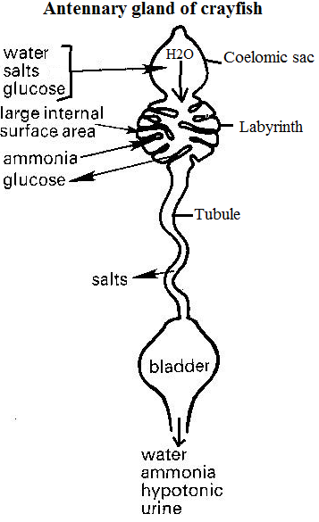
 | - Crayfish
Here antennal glands are capable of eliminating excess water but reabsorb salts, resulting into production of urine hypotonic with blood and an internal osmotic pressure (opi) higher than external osmotic pressure (ope).
Reabsorption of salts occurs as the urine flows along the coiled tubule

The graph below shows changes in internal osmotic pressure of blood (opi) with external osmotic pressure in the surrounding medium (ope) in marine invertebrates.
[Figure 14.9 Roberts MBV: Biology a functional approach, 4th ed. Page 220 or Colin Clegg (1981), Biology for schools and colleges, page 186]
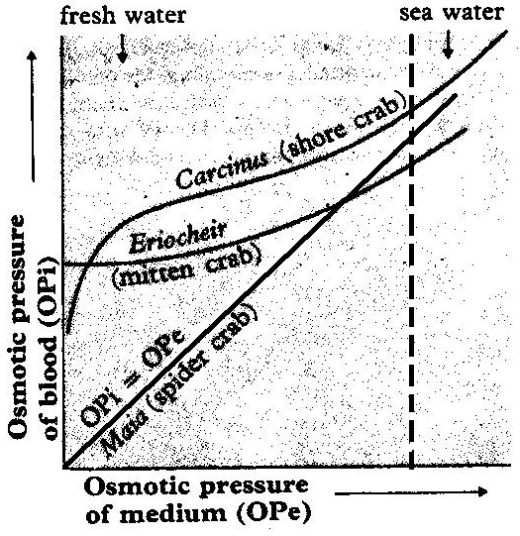
Explanation for the variations in internal pressure
In the body fluids of marine invertebrates, the concentrations of the various ions are usually different from those in the surrounding sea water.
Carcinus Variation: Opi of carcinus is low in fresh water (fw), increases rapidly with slight increase in Ope, then increases slowly thereafter with increase of external concentration. Osmoregulation breaks down and opi increases rapidly with transition into highly concentrated external medium / sea water (sw).
Explanation: Marine Crustacea experiencing reduced salinities are subjected to osmotic influx of water from the surrounding medium. In Carcinus maenas, urine production increases with progressive dilution of the medium to prevent increase in internal volume and hydrostatic pressure which would rise to a lethal level. E.g. transfer of crabs from 100 % to 50% sea water results in increased urine production within 5 minutes of dilution of the medium.
Likely habitat: estuarine / brackish water (neither fresh water nor sea water)
Eriocheir: Variation: Opi of Eriocheir is relatively constant in fresh water, slightly increases with salinity, save with too much concentration.
Explanation: Eriocheir has osmoregulatory abilities even with much dilution except in highly concentrated external medium.
Likely habitat: fresh and brackish water
Maia: variation: A change in ope results in a similar change in opi of blood, which is an indicator that Maia cannot osmoregulate at all. Likely habitats include Fresh water, sea water and brackish water

Description of excretion and osmoregulation in a terrestrial insect
Osmoregulation | Excretion
A terrestrial insect is liable to water loss, which is minimized by:  -An impermeable cuticular covering coated with wax  -Production of non-toxic and almost insoluble waste product, uric acid which requires little water for its elimination being almost no toxic.  -Reabsorption of water by malpighian tubules and rectal glands, resulting in very concentrated urine.  -Laying cleidoic eggs such that water loss is prevented during embryo development by a relatively impermeable shell.  -Possession of valve-like structures and hair in the spiracles to reduce on water loss | -The peristaltic movements of malpighian tubules stir up the coelomic fluid (blood) enabling epithelial cells to absorb nitrogenous wastes like sodium and potassium urate.  -Within the tubule cells, Water and CO₂ react with potassium urate to form potassium hydrogen carbonate and uric acid.  -Potassium hydrogen carbonate is absorbed back into blood while uric acid is deposited in the tubule lumen.  -As the uric acid moves from distal to proximal end of the malpighian tubule, water is vigorously back into blood while solid crystals of uric acid are deposited in the lumen and later rectum to be passed out.
Draw figures 14.14 A and B Roberts MBV: Biology a functional approach, 4th ed. Page 226
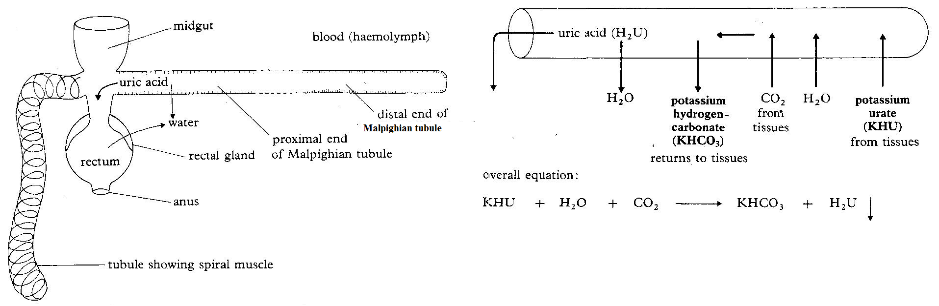

Description of osmoregulation in fresh water protozoa e.g. amoeba or paramecium
- Contractile vacuoles carry out smoregulation in fresh water protozoa.
-Since the cell contents are hypertonic to the surrounding, and the cell membrane is partially permeable, there is constant influx of water into the cytoplasm by osmosis.
-Small vesicles in the cytoplasm fill up with fluid from the cytoplasm and pump salts back into the cytoplasm by active transport, using energy provided by ATP from the numerous mitochondria surrounding the vesicles.
-The vesicles, now containing water fuse with the contractile vacuole which gradually expands.
-The impermeability of the vacuolar membrane to water prevents osmotic out flow of water.
-On reaching critical size, the contractile vacuole fuses with the cell surface membrane, contracts suddenly and releases its water. Roberts MBV: Biology a functional approach, 4th ed. Page 221, also read Taylor DJ etal: Biological science pg676-678
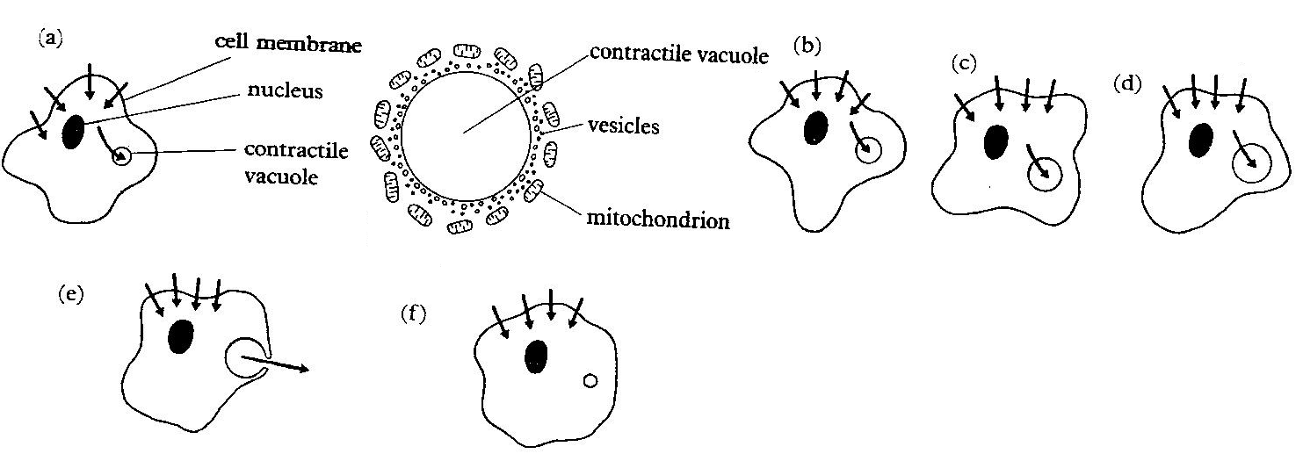

Sample question: Two species of amoeba were transferred from their natural habitats to different dilutions of sea water, and each individual was given time to adjust to its new environment. The table below shows data about the rate of vacuolar contractions with varying solute concentrations. [Susan & Glenn Toole (1991), 2nd edition, pg.527]
 | Number of vacuolar contractions per hour
Sea water concentration in %  (normal sea water = 100%) | Species A | Species B
5  10  15  20  30  40  50  60 | 82  74  65  58  34  14  0  0 | 20  63  64  56  31  13  6  0

(a) Plot the results of the experiment as a graph
(b) Describe the functioning of the contractile vacuole.
(c) Explain by reference to the data, the difference in vacuolar contraction in the two species of Amoeba when placed in the higher concentrations of seawater.
(d) What information may be deduced about the natural habitats of the two species from the rates of vacuolar contractions?

OSMOREGULATION AND EXCRETION IN FRESH WATER BONY FISH (TELEOSTS), MARINE TELEOSTS, MARINE ELASMOBRANCHS AND MIGRATORY FISHES.

Fresh water teleosts (bony fish) e.g. tilapia, stickle back, trout, etc  (Opi > Ope) | Marine teleosts  e.g. cod, mackerel (Opi < Ope) | Marine elasmobranchs (cartilaginous fish) e.g. dog fish, sharks, rays | Migratory fishes e.g. salmon and eels
The excretory and osmoregulatory organs are the gills and kidneys.  Internal body fluids being hypertonic to the surrounding water, there is:  i) Osmotic influx of water across the gills, lining of mouth and pharynx.  ii) Efflux of solutes (ions and ammonia) into water by diffusion.  -Problem (i) is addressed by not drinking water and production of large volume of dilute (hypotonic) urine.  -Problem (ii) is addressed by reabsorbing ions across the nephron tubules, from the glomerular filtrate back into blood. The high glomerular filtration rate is enabled by numerous large glomeruli in the kidneys. In addition, there is active uptake of salts from water by chloride secretory cells in the gills. | - The excretory and osmoregulatory organs in marine teleosts are the gills and kidneys.  Internal body fluids being hypotonic to the surrounding water, there is osmotic extraction of water from the body leading to dehydration of the tissues, a situation described as ‘physiological drought’. This is overcome by:  -Drinking large amounts of seawater and having a kidney with low filtration rate enabled by few small sized glomeruli.  - The ions Ca²⁺, Mg²⁺ and SO₄²⁻ (divalent ions) in the seawater a marine fish drinks are eliminated through the anus while K⁺, Na⁺, and Cl⁻ (monovalent ions) are absorbed into blood and are actively transported out of blood across the gills, reverse to the direction in fresh water fish.. The divalent ions that enter blood are secreted into the nephron tubules and excreted in urine.  -Excreting trimethylamine oxide, which is soluble but non-toxic requiring little water for elimination | - Their tissue fluid is slightly hypertonic to seawater, causing slight influx of water, which is readily expelled by the kidneys.  - Hypertonic tissue fluid results from urea retention, which is facilitated by:  -Impermeability of gills to urea.  -Urea reabsorption from the nephron tubules, maintaining its concentration at over 100 times higher than that in mammals.  -Tolerance of tissues and enzymes to high urea concentration.  -The highly toxic urea is detoxified by TriMethylamine Oxide (TMAO) | These are fish that keep moving from one extreme osmotic environment (sea) to another (fresh water) during lifetime. This is achieved through adjustments like:  -Changes in kidney filtration rate.  -Reversal of the direction in which the chloride secretory cells transfer salt i.e. in fresh water they take in salt and may move them outwards in seawater.

OSMOREGULATION IN TERRESTRIAL VERTEBRATES:
Terrestrial animals are liable to water loss to the atmosphere and must overcome this to be able to survive.
How terrestrial animals gain water | How terrestrial animals lose water
(1) By drinking directly (2) taken along with food (3) from metabolic by-product e.g. respiratory product | (1) In urine (2) Faeces (3) Sweating (4) Evaporation from lungs (5) External secretions e.g. tears

Physiological adaptations against water loss | Structural / morphological adaptation | Behaviuoral adaptations
- Reduction in glomerular filtration rate e.g. the desert frog, chiroleptes has few and smaller glomeruli than its relatives living in moist temperate regions.  - Production of non-toxic nitrogenous waste e.g. the insoluble uric acid (reptiles, birds and insects) and the relatively less toxic urea (mammals and amphibians) that require little water for removal.  - Extensive water reabsorption from glomerular filtrate (mammals and birds) and rectum (insects). E.g. kangaroo rat has an extra long loop of Henle enabling it to produce hypertonic urine.  - Use of metabolic water from fat through respiration. This explains why desert animals like kangaroo rat (Dipodomys) mostly metabolise fat, which yields more water (1 gm yields 1.1gm of water) on oxidation than carbohydrate (1 gm yields 0.6 gm of water) and protein (1 gm yields 0.3 gm of water). Dipodomys may spend its entire life without drinking water.  - Possession of tissues tolerant to dehydration. E.g. a Camel can survive for a week without drinking water, but can gulp 80 litres in 10 minutes.  - Ability to sweat at abnormally higher temperature e.g. a camel begins sweating at 41⁰C from its normal body temperature of 34⁰C  - Ability to reduce the need for nitrogenous excretion e.g. a camel secretes urea into the lumen of alimentary canal where bacteria convert it to protein, which is then utilized as food. | Possession of waterproof integuments, which include the keratinous scales of reptiles, cornified epithelium of mammals and the waxy cuticle of insects. | - Change of habitat depending on the weather conditions.  - Some animals e.g. African lungfish aestivate.  Aestivation is seasonal response by animals to drought or excessive heat during which they become dormant, body temperature and metabolic rate fall to the minimum required for maintaining the vital activities of the body. It is an adaptation for temperature regulation as well as water conservation.  During aestivation, the African lungfish burrows down and encases in a cocoon of hard mud lined with mucus

OSMOREGULATION IN AMPHIBIANS AND REPTILES
Amphibians being the first terrestrial vertebrates, their kidney is identical to that of fresh water fishes.
(1) Body fluids of amphibian are hypertonic to fresh water resulting in (i) osmotic influx of water which is readily lost by the kidneys expelling large volumes of urine (ii) salt loss by diffusion which are replaced actively across the skin (2) During aestivation, amphibia instead of the usual ammonia form urea, which is less toxic and therefore can be retained until water is available for excretion (3) Amphibia never drink water hence water gain is osmotic via the skin or in food consumed.

Reptiles on the other hand live in diverse habitats:
- Those living mainly in fresh water e.g. some crocodiles possess kidneys like those of fresh water fishes and amphibians.
- Marine reptiles e.g. some crocodiles, turtles, sea snakes and some lizards e.g. iguana possess kidneys similar to those of their fresh water relatives. However, since these kidneys reabsorb salt, marine reptiles cannot excrete a great deal of salt in their urine. Instead, they eliminate excess salt by means of salt secreting glands located near the nose or the eye, hence ‘the turtle shedding tears. Terrestrial reptiles reabsorb much of the salt and water in the nephron tubules of kidneys, helping somewhat to conserve blood volume in dry environments. Like amphibians and fishes, though, they cannot produce urine that is more concentrated than the blood plasma.
Reptiles minimize water loss by (1) laying cleidoic eggs with waterproof embryonic membranes and supporting shell (2) possession of waterproof keratinized skin and scales (3) possession of kidneys with reduced glomeruli hence low rate of glomerular filtration (3) production of insoluble uric acid which is almost non-toxic and therefore requires little water for elimination (4) absorption of water by the cloaca from faeces and nitrogenous wastes.

EXCRETION AND OSMOREGULATION IN MAMMALS AND BIRDS
Mammals and birds are the only vertebrates with loops of Henle, enabling their kidneys to produce urine that has a higher osmotic concentration than their body fluids. This enables them to excrete waste products in a small volume of water, so that more water can be retained in the body. E.g. Human kidneys can produce urine that is 4.2 times as concentrated as their blood plasma, the camel, gerbil and pocket mouse can excrete urine 8, 14 and 22 times as concentrated as their blood plasma, respectively.
Birds, however, have relatively few or no nephrons but with long loops, so they cannot produce urine that is as concentrated as that of mammals. Marine birds e.g. penguins, gulls and cormorants drink salt water and then excrete the excess salt from salt secreting nasal glands near the eyes, giving an impression that these birds have runny noses.
Mammalian excretory organs include the lungs, skin, liver and kidneys, which are the main excretory organs.

AN OUTLINE OF THE FUNCTIONS OF THE KIDNEYS
(1)Excretion of metabolic waste products such as urea, excess water, uric acid, ammonia, creatine etc (2) Regulation of water and solute content of blood (osmoregulation) (3) Maintenance of PH of body fluids at 7.4 (acid-base balance by removing or neutralizing excess acidity / alkalinity (4) Regulation of blood levels of electrolytes such as Na⁺, K⁺, Cl⁻, Ca²⁺
(5) Secretion of the hormone erythropoietin, which stimulates red blood cell production for transporting oxygen (6) Retention of important nutrients such as glucose and amino acids through reabsorption from glomerular filtrate into blood.
Structure of mammalian kidney (Figure 14.1 A, B and C Roberts MBV: Biology a functional approach, 4th ed. Page 211 & fig. 51.3 Raven Peter .H and Johnson George .B: biology, 4th ed. Page 1148) or Freeman W.H. & B. Bracegirdle (1984), Atlas of histology, P. 77
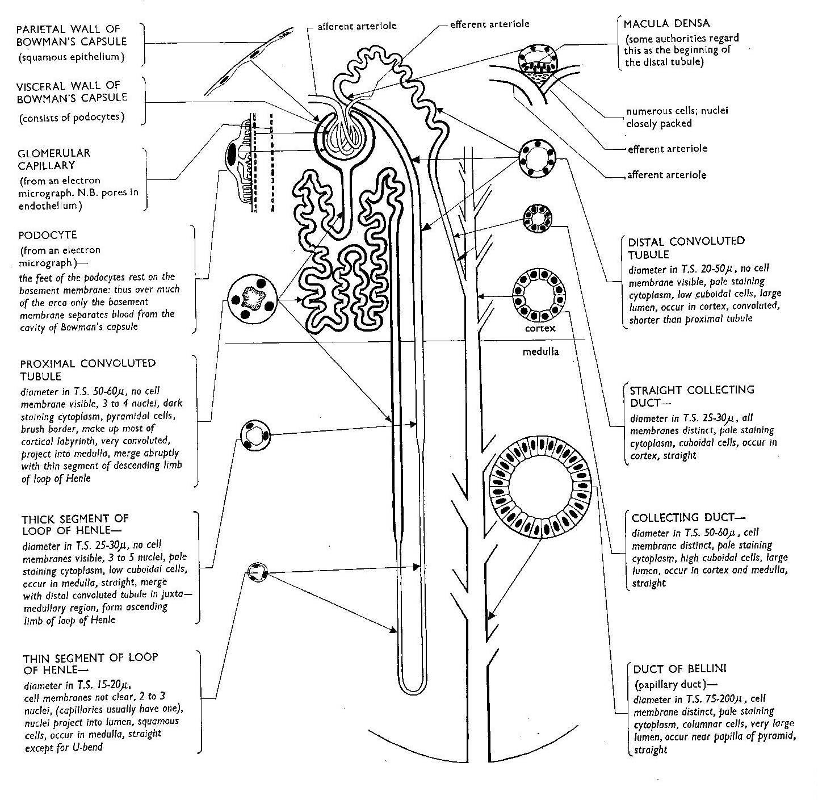

A DESCRIPTION OF THE MAIN HOMEOSTATIC FUNCTIONS OF THE KIDNEYS:

A nephron consists of (1) Bowman’s capsule (2) glomerulus (3) proximal tubule (4) loop of Henle (5) distal tubule

EXCRETORY FUNCTION OF THE KIDNEY
The nephron accomplishes its excretory function by these separate processes which occur at the different regions of the:
(i) Ultra filtration (pressure filtration) at the glomerulus of Bowman’s capsule (ii) Selective reabsorption in the tubules (iii) Tubular secretion at the proximal and distal convoluted tubules (iv) Counter current multiplier effect in the loop of Henle (v) Water reabsorption in the distal convoluted tubule and collecting duct.
Process | Explanation and Description
Ultra filtration (pressure filtration) in the bowman’s capsule  (Fig 17.5 A and B Michael Roberts & Reiss, etal: Advanced Biology, 1st ed. 2000 Page 283)  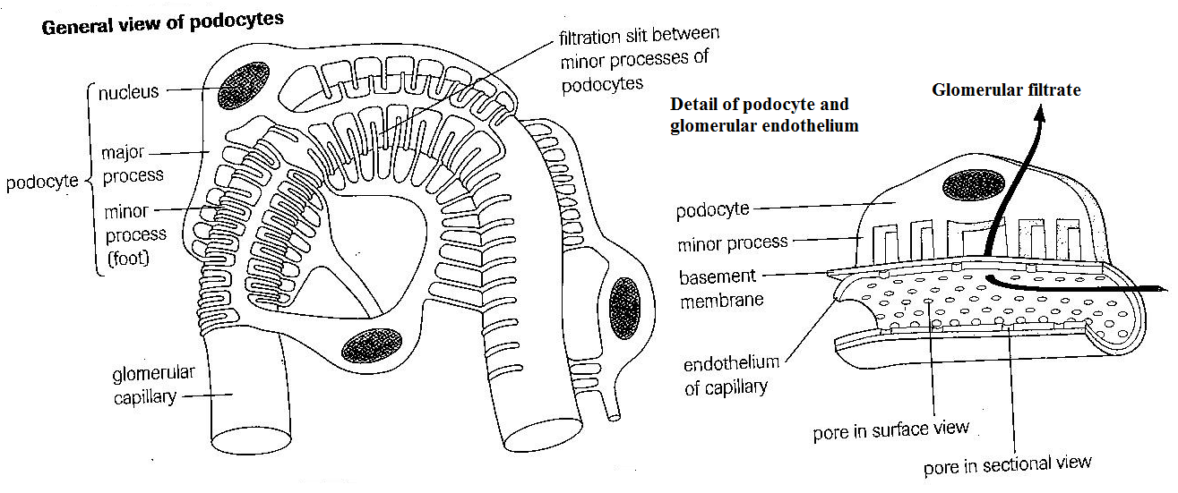 | This is the first stage of urine formation at the glomerular capillary wall of kidney nephrons during which hydrostatic pressure forces small molecules in blood of glomerular capillaries to pass across the basement membrane into the capsular space but large molecules are held back.  The substances that are forced by pressure to pass passively across the fine basement membrane filter include small molecules like water, glucose, amino acids, vitamins, urea, uric acid, ions, creatine, and some hormones while the large substances retained in blood include red blood cells, platelets, white blood cells and large sized plasma proteins.  Although filtration occurs through three layers of glomerular capillary, the endothelium is a coarse screen retaining only blood cells, the negatively charged basement membrane retains negatively charged large sized protein, while the selective filtration occurs at the diaphragms of slit pores formed by foot-like projections of supporting cells called podocytes  The high hydrostatic pressure of blood in the glomerulus which facilitates ultrafiltration results from the afferent arteriole having a larger diameter than the efferent arteriole.
Selective reabsorption from the tubules [ MBV Roberts (4th ed)]  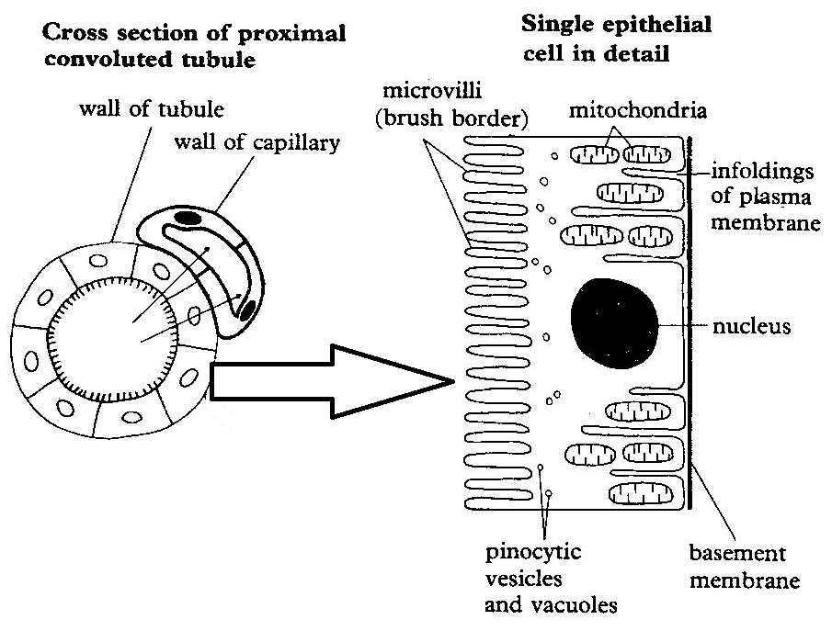 | Because particle size rather than their importance determines the substances to pass through the basement membrane during ultra filtration, useful substances such as glucose enter the capsular space to form glomerular filtrate and have to be reabsorbed later.  As the glomerular filtrate (renal fluid) flows along the tubule of the nephron, all the glucose, 85% of the water, Na⁺, Cl⁻, amino acids, vitamins, hormones, 50% of urea are reabsorbed from the proximal convoluted tubule into the surrounding blood capillaries.  Glucose, amino acids and Na⁺, H₂PO₄⁻ and HCO₃⁻ are co-transported into proximal tubule cells passively and then actively pumped into the blood capillaries.  The active uptake of Na⁺ followed by the passive uptake of Cl⁻ raises the osmotic pressure in the cells enabling entry of water into capillaries by osmosis.  50% of urea is reabsorbed by diffusion but the small sized proteins in the renal filtrate are removed by pinocytosis. As a result of all this activity, the tubular filtrate is isotonic with blood in the surrounding capillaries
Tubular secretion at the proximal convolulated tubule | Finally, active secretion of unwanted substances like creatine, some urea, ammonia, uric acid, H⁺, and K⁺ occurs from blood capillaries into the proximal tubule
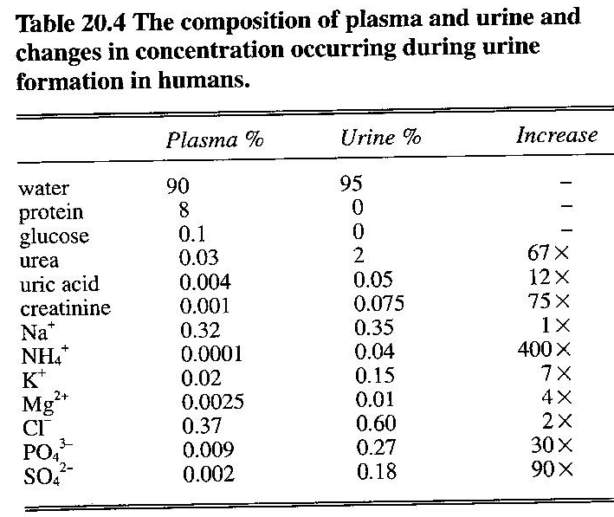
Concentrations of substances in the blood
and in the glomerular filtrate

NB: Only birds and mammals have loops of Henle in their Kidneys enabling production of hypertonic urine
Process |  | Definition, Explanation and Description
Counter current multiplier effect in the loop of Henle  (Kent Michael, 1st ed. 2000 Page 149) or MBV Roberts 4th ed. P. 217)  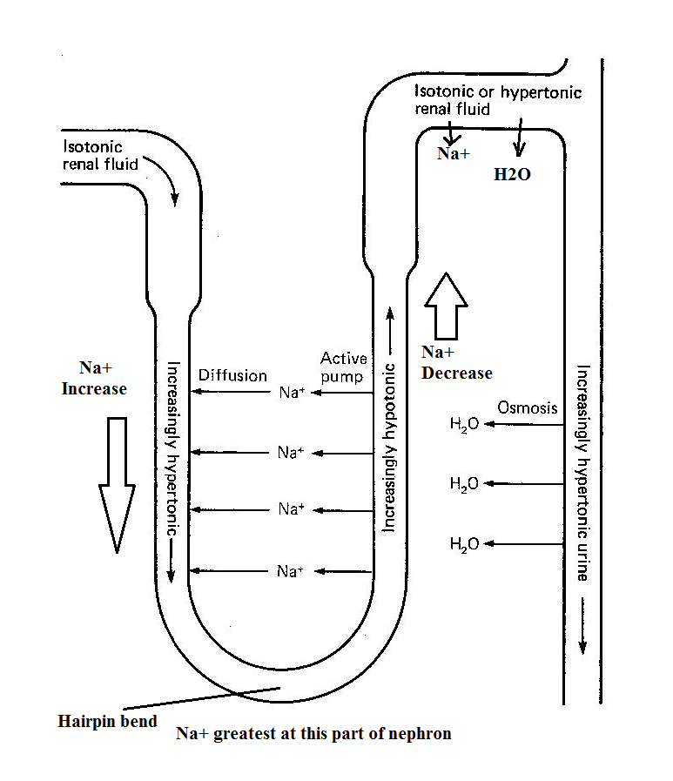 |  | A system of parallel and opposite flow of renal fluid in the descending and ascending limbs of the loop of Henle in the kidney with active salt concentration in the medullary interstitial tissue, an increase in salt concentration in the renal fluid of the descending limb and a decrease in salt concentration in the ascending limb to cause production of hypertonic urine  The loop of Henle is the counter current multiplier and the vasa recta is the counter current exchanger. If the vasa recta did not exist, the high concentration of solutes in the medullary interstitium would be washed out.  The ascending limb of the loop of Henle is relatively impermeable to water while the descending limb is freely permeable to water but relatively impermeable to salt and urea.  Na⁺ are actively pumped out while K⁺, Cl⁻ and other ions are co-transported out of the upper part of ascending limb, but diffuse from the lower part, raising the solute concentration in the interstitial region and lowering the concentration in the ascending limb.  Water is osmotically drawn from the descending limb and collecting duct and carried away by blood in the vasa recta, resulting into a slightly higher solute concentration in the descending limb than the adjacent ascending limb and hypertonic urine to form.  The concentrating effect is multiplied such that the fluid in and around the loop of Henle becomes saltier with the saltiest region being the hairpin bend.  The glomerular filtrate becomes less salty as it goes up the ascending limb
Water reabsorption in the distal convoluted tubule and collecting duct | This is under the influence of hormones as discussed on page 8 under osmotic regulation  As the fluid flows down the collecting duct, water is drawn out of it osmotically into the interstitium, resulting in hypertonic urine production

The major factors that contribute to the buildup of solute concentrations into the

Adaptations of proximal convoluted tubule cells to reabsorption
- Possession of numerous microvilli (extensive brush boarder) at the free end (luminal /apical end) to increase the surface area for reabsorption.
- Contain numerous mitochondria to form ATP that provide energy required in active transport of glucose, amino acids, Na⁺, H₂PO₄⁻ and HCO₃⁻ into the blood capillaries
- The cell surface membrane is indented to form a large area of intercellular spaces bathed with fluid.
- Numerous pinocytic vesicles, which enable the digestion of small protein molecules from the renal filtrate.
- Form a thin thickness of one cell layer to ease reabsorption of substances.
- Many protein carrier molecules in membrane surface of epithelial brush boarder for transporting sodium ions.
- Tubular secretion of H⁺ enables removal of bicarbonate ions from the tubule by combining with H⁺ with HCO₃⁻ to form H₂CO₃ which then dissociates into CO₂ and H₂O

CHANGES IN CONCENTRATION OF SUBSTANCES IN DIFFERENT PARTS OF THE NEPHRON
What is renal-plasma ratio?
The ratio obtained after dividing the concentration of substances in renal fluid / tubular fluid by the concentration of same substances in blood plasma.

The figure below shows variation in concentration of cations (K⁺, Na⁺), inorganic anions (HCO₃⁻, Cl⁻), organic anion (p-aminohippurate - PAH), inulin, (a fructose Polymer), excretory wastes (Urea and Creatinine – a product of muscle metabolism derived from creatine phosphate), and metabolites (glucose, amino acids and protein of low molecular weight) along the different regions of the nephron. Inulin is not synthesized, destroyed, or stored in the kidneys.

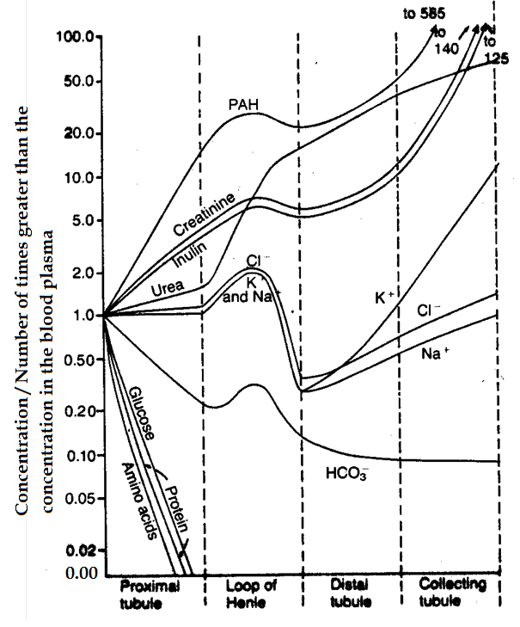
INTERPRETATION OF RENAL-PLASMA RATIOS
All the values in the graph represent the renal fluid concentration of a particular substance divided by the plasma concentration of that substance.
If the plasma concentration of a substance is assumed to be constant, any change in the ratio of renal fluid/plasma concentration rate indicates changes in renal fluid concentration.
A value of 1.0 indicates that the concentration of the substance in the glomerular filtrate / renal fluid is the same as the concentration of that substance in the plasma.
Values below 1.0 indicate that the substance is reabsorbed more greatly than water.
Values above 1.0 indicate that more water is reabsorbed than solute or there was net secretion of the substance into the renal fluid.
Substances whose concentrations increase above 1.0 are unwanted by the body (e.g. creatinine), are not or just slightly reabsorbed hence become highly concentrated in urine to be eliminated.
Substances whose concentrations decrease below 1.0 are needed by the body (e.g. glucose, amino acids), are greatly reabsorbed hence almost none is lost in urine.

OBSERVATIONS AND EXPLANATION
1. At the point of entry into the proximal tubule, the concentration of all components in the graph is the same in the glomerular filtrate and the blood plasma, thus the ratio of 1.0 because re-absorption has not yet occurred.

2. AS THE FLUID FLOWS ALONG THE PROXIMAL TUBULE:
Concentration of PAH, Creatinine and Inulin increase rapidly; for urea and Chloride ions increase gradually; for Sodium and potassium remain constant because:
(i) Large volume of water is reabsorbed into capillaries osmotically, increasing the concentration of unabsorbed and partly absorbed substances;
(ii) Urea is passively reabsorbed (50% absorption) passively from renal fluid through the PCT into blood; Osmotic reabsorption of water coupled to sodium reabsorption increases the concentration of urea in the tubule lumen, which creates a concentration gradient that favours reabsorption of urea.
(iii) Many Chloride, Sodium and Potassium ions are reabsorbed from renal fluid into blood capillaries;
(iv) PAH, Creatinine and Inulin (just like Uric acid) are not reabsorbed; Creatinine is a relatively large molecule that is impermeant to the tubular membrane hence almost none of the creatine that is filtered is reabsorbed resulting in almost all the creatine filtered by the glomerulus to be excreted in urine;
Glucose, Amino acids and protein concentration decreases rapidly along the PCT until none is left; because all are reabsorbed into capillaries along the PCT;
Bicarbonate ion concentration decreases rapidly along the PCT because of reabsorption into capillaries;

3. LOOP OF HENLE
In the first half of the loop of Henle (descending limb) concentration of Na⁺, K⁺, Cl⁻ and HCO₃⁻ ions increases rapidly to a maximum as concentration of PAH, inulin and creatine increases gradually; while in the second half of the loop of Henle (ascending limb) concentration of Na⁺, K⁺, Cl⁻ and HCO₃⁻ ions decreases rapidly as concentration of PAH, inulin and creatine decreases gradually;
This is because the wall of the descending limb of the loop of Henle is impermeable to most solutes but permeable to water; while the wall of the ascending limb of the loop of Henle is impermeable to water but permeable to most solutes;
Throughout the loop of Henle except the part close to the distal proximal tubule, the urea concentration increases rapidly.

4. DISTAL TUBULE AND COLLECTING DUCT IN THE CORTEX REGION
The early distal tubule (just after the thick ascending limb of loop of Henle) and collecting duct in the cortex region of the kidney reabsorb Na⁺, Cl⁻, Ca²⁺ and Mg²⁺ but almost impermeable to water and urea, although some reabsorption of urea occurs in the medullary collecting duct.
Two types of cells in the late distal tubule (towards collecting duct) and cortical collecting duct:
(i) The principal cells, which reabsorb Na⁺ ions and H₂O from the lumen and secrete K⁺ ions into the lumen.
The rate of reabsorption of Na⁺ and K⁺ is controlled by hormones (e.g. aldosterone) and other factors (e.g. concentration of K⁺ in the body)
(ii) The intercalated cells, which reabsorb K⁺ and HCO₃⁻ ions from the lumen and secrete H⁺ ions into the tubular lumen by an active H⁺-ATPase mechanism, capable of pumping H⁺ into the lumen, against their concentration gradient of as high as 1000 to 1, which is between 4 to 10 times greater than active secondary secretion of H⁺ in the proximal convoluted tubule.
Therefore, the distal convoluted tubule is the main site of the nephron for acid-base balance.

The reabsorption of water from the late distal tubule and cortical collecting duct depends on the concentration of Antidiuretic hormone (Vasopressin):
(i) High concentration of ADH increases permeability of the tubule to water, enabling much water reabsorption into the body, resulting in production of little urine which highly concentrated with solutes.
(ii) Absence of ADH results in impermeability of the tubule to water, hence retention of water in the tubule, causing production of dilute urine.

5. COLLECTING DUCT IN THE MEDULLA REGION OF KIDNEY
Cells are cuboidal in shape, with smooth surfaces and few mitochondria.
Permeability to water is controlled by the level of ADH:
(i) High ADH levels increase tubular permeability for water reabsorption into medullary interstitium, thereby decreasing urine volume but increasing solute concentration in urine.
(ii) Absence of ADH causes impermeability of tubule to water, resulting in no / little water reabsorption, increasing urine volume and dilution.
The medullary collecting duct is permeable to urea, unlike the cortical collecting duct. Therefore, some of the tubular urea is reabsorbed into the medullary interstitium, thereby increasing osmolality in the kidney medulla, which enables production of concentrated urine.
The medullary collecting duct also secretes H⁺ against a large concentration gradient hence plays a major role in acid-base balance.

6. INULIN TUBULAR FLUID / PLASMA CONCENTRATION RATIO
The tubular fluid / plasma concentration ratio for Inulin can be used to measure water reabsorption by renal tubules because Inulin, a polysaccharide is neither reabsorbed nor secreted by the renal tubules, therefore changes in inulin concentration at different parts along the renal tubule reflect changes in the amount water present in the tubular fluid.

For example The tubular fluid / plasma concentration for inulin of 3.0 at the end of PCT indicates that:
(i) Inulin concentration in the tubular fluid is 3 times greater than in the plasma and in the glomerular filtrate.
(ii) Only 1/3 of water that was filtered remains in the renal tubule and 2/3 of the filtered water has been reabsorbed because inulin is neither absorbed nor secreted.
The tubular fluid / plasma concentration for inulin of 125 at the end of collecting duct indicates that:
(iii) Only 1/125 of water that was filtered remains in the renal tubule and 99% of the filtered water has been reabsorbed.

The glomerular filtration rate and its determinants:
Glomerular filtration rate (GFR) is the net rate of formation of filtrate by the two kidneys. GFR is equal to the renal plasma flow (RPF) rate (the rate of plasma flow through the renal arteries) multiplied by the fraction of this plasma flow that is filtered (the filtered fraction, FF),
GFR = (RPF) x (FF)
E.g. Creatinine filtration rate = GFR X Plasma creatinine concentration
= Creatinine excretion rate

FF is determined by three factors: (i) filtration pressure across the glomerular capillary walls (ii) permeability of the renal filter to fluid (iii) the total surface area available for filtration.
The kidneys receive a large part of the total cardiac output: for a typical cardiac output of 5.6 litres per minute, the kidneys might receive about 1.2 litres per minute, or about 20%.
GFR increases (i) if the mean glomerular capillary pressure rises as a result of either dilation of the afferent arterioles or constriction of efferent arterioles, or (ii) if the concentration of plasma proteins falls, because this reduces the force favouring reabsorption.
GFR decreases if (i) the hydrostatic pressure in bowman’s capsule rises (e.g. if the ureters are blocked) or (ii) plasma proteins escape into Bowman’s capsule, because protein in Bowman’s capsule makes net osmotic force across the glomerular wall smaller.
As a consequence of net reabsorption of solute, the volume of fluid in the nephrons decreases, until only about 1% or 2% of the original filtrate volume reaches the ureters as final urine.

The adaptive significance of formation of urine by filtration in the glomerulus followed by reabsorption and secretion in the later parts of the nephrons is to enable the kidney excrete soluble chemicals that might enter the body, e.g. drugs and bacterial toxins but for which there are no specific tubular reabsorption pathways.

Why urine production almost stops after serious bleeding:
The amount of urine produced is proportional to the amount of blood flowing through the kidneys. The total blood volume in the body reduces if serious bleeding occurs, resulting into diversion of blood from other tissues (including the kidneys) to the brain to maintain life. Therefore the volume of blood flowing through the kidneys reduces greatly to the extent that less ultrafiltration and hence formation urine occurs.

REGULATION OF ACID-BASE BALANCE
The three major systems that regulate the H⁺ concentration in the body fluids to prevent acidosis or alkalosis:
1. The Chemical acid-base buffer systems of the body fluids, which react within a fraction of a second to minimize changes in PH. Buffer systems do not eliminate H⁺ from or add them to the body but only keep them tied up until balance can be reestablished.
2. The respiratory centre, which immediately remove CO₂ (and, therefore, H₂CO₃) from the extracellular fluid;
3. The kidneys, which can excrete either acid or alkaline urine, thereby readjusting the extracellular fluid H⁺ concentration toward normal during acidosis or alkalosis.

NOTE:
Kidneys are by far the most powerful of the acid-base regulatory systems, but work slowly.

Alkalosis refers to excess removal of H⁺ from the body fluids.
Acidosis is the excess addition of H⁺ to body fluids.

IMPORTANCE OF REGULATING pH OF BODY FLUIDS
Regulation of H⁺ within narrow limits is essential because enzymes work in narrow PH ranges, which if allowed to vary greatly would inhibit enzyme catalysed reactions, resulting in death.

pH OF BODY FLUIDS
The normal pH of arterial blood is 7.4, whereas the pH of venous blood and interstitial fluids is about 7.35 because of the extra amounts of carbon dioxide (CO₂) released from the tissues to form H₂CO₃ in these fluids.
Body pH above 7.4, a person experiences acidosis while below 7.4 is described as alkalosis.
The lower and upper pH limits for human body survival are 6.8 and 8.0 respectively.

1. CHEMICAL BUFFER SYSTEMS IN BODY FLUIDS
Definition of buffer: A weak acid plus its conjugate base that cause a solution to resist changes in pH when an acid or base are added. The general form of the buffering reaction is: Buffer + H⁺ HBuffer

When H+ concentration increases, the reaction is forced to the right, and more H+ binds to the buffer, as long as buffer is available while a decrease in H+ concentration causes the reaction to shift toward the left. So as to minimise changes in H+ concentration.
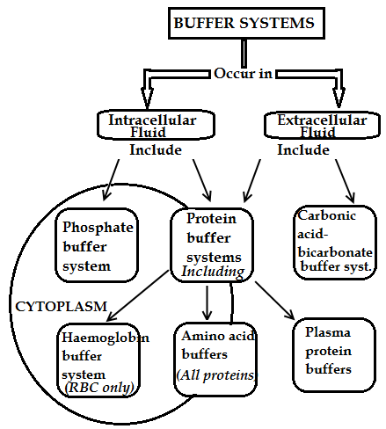

SOURCES OF HYDROGEN H+ IONS
-Aerobic and anaerobic respiration of glucose
-Incomplete oxidation of fatty acids
-Oxidation of Sulphur-containing amino acids
-Hydrolysis of phosphoproteins and nucleic acids

A. CARBONIC ACID - BICARBONATE BUFFER SYSTEM
Though also present in intracellular fluid, the Bicarbonate buffer system is most important in extracellular fluid.
The bicarbonate buffer system consists of a water solution with two ingredients:
(i) a weak acid called carbonic acid (H₂CO₃)
(ii) a weak base called bicarbonate ion from a salt, such as NaHCO₃.

H₂CO₃ is formed in the body by the reaction of CO₂ with H₂O catalysed by the enzyme carbonic anhydrase.
Carbonic anhydrase enzyme Carbonic anhydrase enzyme
CO₂ + H₂O H₂CO₃ H⁺ + HCO₃⁻

During acidosis, the NaHCO₃ dissociates to form bicarbonate ions which combine with excess hydrogen ions to form carbonic acid, which dissociates into water and carbon dioxide, which can be eliminated by the respiratory system as pH is increased to the norm.
During alkalosis, carbon dioxide reacts with water to form carbonic acid (H₂CO₃) which dissociate to form bicarbonate ions and hydrogen ions, which to lower the pH to the norm.

B. PHOSPHATE BUFFER SYSTEM
The main components of the phosphate buffer system are:
(a) Dihydrogen phosphate (H₂PO₄⁻), which is a weak acid.
(b) Hydrogen phosphate (HPO₄²⁻), which is a weak base.

Phosphate Buffer System
Only functions when there is excess H⁺ in the renal tubules.
Plays Major roles in renal tubules (urine) and intracellular fluid where phosphate concentrations are high.
 Plays Minor role in extracellular fluid because the concentration of phosphate in the extracellular fluid is low.

HOW PHOSPHATE BUFFER SYSTEM MAINTAINS pH
When pH increases (alkalosis), dihydrogen phosphate dissociates into hydrogen ions and monohydrogen phosphate ions, to lower pH to the norm.
H₂PO₄⁻ H⁺ + HPO₄⁻

When pH decreases (acidosis), hydrogen ions react with monohydrogen phosphate ions to form dihydrogen phosphate, to increase pH to the norm.
H⁺ + HPO₄⁻ H₂PO₄⁻

C. PROTEIN BUFFER SYSTEM
Approximately 60% to 70% of the total chemical buffering of the body fluids is inside the cells, and most of this results from the intracellular proteins.
The protein buffer system is important in extracellular system and intracellular fluid.

The protein buffer system is composed of:
(i) Haemoglobin buffer system inside red blood cells
(ii) Plasma protein buffers
(iii) Amino acid buffers by all proteins

Haemoglobin buffer system
This is mainly important for carbon dioxide.
During acidosis, the haemoglobin (Hb) in red blood cells binds with H⁺ to increase intracellular pH and release oxygen by the process called Bohr effect.
During alkalosis and in the presence of oxygen, H⁺ ions are released from haemoglobin, a process called the Haldane effect, which decreases intracellular pH.
H⁺ + Hb HHb

Plasma protein and Amino acid buffer systems
During acidosis (increased acidity), the exposed amino group of amino acids like histidine accepts H⁺ to decrease acidity for plasma proteins like albumin.
During alkalosis, the exposed carboxyl group of amino acids can release H⁺ to increase acidity.

2. HOW THE KIDNEY MAINTAINS ACID-BASE BALANCE
The kidneys regulate extracellular fluid H⁺ concentration through three major mechanisms:
(a) Secretion of H⁺ into urine for excretion.
(b) Conserving (Reabsorption) the filtered HCO₃⁻ from urine or forming new bicarbonate from glutamine metabolism so as to decrease the acidity of extracellular fluid.
(c) Excreting HCO₃⁻ so as to increase the acidity of extracellular fluid.

Renal mechanisms of Acid – Base balance

During alkalosis (decreased extracellular concentration of H⁺), the excretion of bicarbonate in urine increases. Because HCO₃– normally buffers hydrogen in the extracellular fluid, the loss of bicarbonate is the same as adding an H⁺ to the extracellular fluid, which restores H⁺ to normal.

During acidosis (increased extracellular concentration of H⁺), the tubular cells reabsorb much bicarbonate ion (HCO₃–), which is added back to the extracellular fluid to restore H⁺ to the norm.

 Extreme Acidosis (excessive extracellular concentration of H⁺) stimulates the enzyme glutaminase to metabolise glutamine inside collecting duct cells (and proximal tubule cells) to form Ammonia and HCO₃–. Ammonia diffuses into the tubular lumen along a concentration gradient, where it reacts with the secreted hydrogen ions to form NH₄ ⁺, which is then excreted in urine while the new bicarbonate is added to blood.
The glutamine mainly comes from the metabolism of amino acids in the liver.

NOTE:
(i) Hydrogen ion secretion and bicarbonate reabsorption occur in virtually all parts of the tubules except the descending and ascending thin limbs of the loop of Henle.
(ii) For each bicarbonate reabsorbed, an H⁺ must be secreted.
(iii) About 80% to 90% of the bicarbonate reabsorption (and H+ secretion) occurs in the proximal tubule, so that only a small amount of bicarbonate flows into the distal tubules and collecting ducts.
(iv) Under normal conditions, the amount of H⁺ eliminated by the ammonia buffer system accounts for about 50 per cent of the acid excreted and 50 per cent of the new HCO₃– generated by the kidneys.

BONE BUFFERING OF ACID-BASE IN HUMANS
Bones consist of a matrix composed of inorganic substance called hydroxyapatite and organic substances like collagen and other proteins.
Hydroxyapatite in bones is the major reservoir of carbon dioxide in the body, in form of bicarbonate (HCO₃⁻) ion and carbonate ion CO₃²⁻).
Release of calcium carbonate from bone provides the most important buffering mechanism involved in chronic metabolic acidosis (i.e. renal tubular acidosis)

3. RESPIRATORY REGULATION OF ACID-BASE BALANCE
Respiratory regulation refers to changes in pH due to changes in partial pressure of carbon dioxide caused by changes in ventilation rates.
Respiring cells release CO₂ from aerobic respiration, which is converted to bicarbonate and H⁺ by carbonic anhydrase enzyme resulting in lower pH in both intracellular and extracellular fluids.
CO₂ + H₂O → H₂CO₃ ⇔ HCO₃⁻ + H⁺
In respiring tissues, carbon dioxide diffuses along a concentration gradient into red blood cells.
-Deoxygenated haemoglobin has strong affinity for both CO₂ and H⁺
-Some carbon dioxide combines reversibly with terminal amino groups on haemoglobin to form carbaminohaemoglobin while other carbon dioxide molecules react with water to form carbonic acid.
-Carbonic acid inside red blood cells dissociates into hydrogen ions and bicarbonate ions, which move out of red blood cells by exchange with chloride ions from blood plasma (Chloride shift) to restore electro neutrality.
In the lungs, bicarbonate ions enter into the red blood cell by exchange with chloride ions into blood plasma.
-The bicarbonate ions react with hydrogen ions to form water and carbon dioxide, which diffuses into the alveoli.

REGULATION OF BLOOD LEVELS OF IONS (Na⁺, K⁺, Cl⁻, Ca²⁺ )
The concentration of any particular type of ion in blood and tissue fluid is regulated in three ways:
i) Hormones control the uptake of the ions into bloodstream from the gut.
ii) Hormones control the removal of ions from the blood by kidneys and elimination in the urine.
iii) Hormones control the release of ions into the bloodstream from reservoirs like organs / tissues e.g. bones in which they are at high concentrations.

A. REGULATION OF CALCIUM IONS (Ca²⁺)
Low blood calcium level stimulates the parathyroid glands (surrounding the thyroid gland) to secrete the parathormone (parathyroid) hormone which increases the calcium level and decreases the hydrogen phosphate (HPO₄²⁻) level through promoting:
- Bone breakdown by osteoclasts
- Calcium retention by kidneys
-Excretion of hydrogen phosphate (HPO₄²⁻) in urine by kidneys
-Activation of vitamin D, which in turn stimulates the absorption of calcium from the gut.

High blood calcium level stimulates the thyroid gland to secrete calcitonin hormone, which increases bone buildup by osteoblasts so as to reduce calcium level.

NOTE:
1. Calcium plays an important role in nervous conduction, muscle contraction and blood clotting.
2. Deficiency of parathyroid hormone results in tetany (shaking of body due to continuous muscle contraction caused by increased excitability of the nerves, which fire spontaneously and without rest)

B. REGULATION OF SODIUM IONS (Na⁺)
A decrease in blood sodium leads to decreased blood volume and reduced blood pressure because less water is drawn into blood by osmosis.
Low levels of sodium in blood are detected by the hypothalamus, which stimulates the anterior pituitary gland to secrete the hormone adrenocorticotropic hormone (ACTH), which stimulates the juxtaglomerular complex (situated between the distal convoluted tubule and afferent arteriole) to release the enzyme Renin (NOT rennin, the digestive enzyme).
Renin catalyses the conversion of angiotensinogen, a plasma protein into a hormone angiotensin which stimulates the adrenal cortex to secrete the hormone Aldosterone
Aldosterone has the following effects:
-Stimulates the active uptake of sodium ions from the glomerular filtrate into the plasma of capillaries surrounding the nephron. This induces osmotic uptake of water into blood thus increasing both the blood volume and sodium level back to the norm, accompanied by loss of potassium ions.
-Stimulates sodium absorption in the gut and decreases loss of sodium in sweat so as to raise sodium levels to cause an osmotic inflow of water thus increasing the blood volume and pressure
-Stimulates the brain to increase the sensation of thirst.

- Increased sodium level in blood causes increased blood volume and pressure, less production of renin and angiotensin resulting in less secretion of aldosterone by the adrenal cortex hence less uptake of sodium from the glomerular filtrate occurs, restoring sodium level to the norm.

REGULATION OF WATER AND SOLUTE CONTENT OF BLOOD (OSMOTIC REGULATION)
Increased concentration of solutes in blood (little water relative to salt) is detected by osmoreceptors in the hypothalamus which stimulate the posterior pituitary to secrete antidiuretic hormone (ADH/vasopressin) and at the same time triggering the sensation of thirst resulting in drinking of water.
ADH increases the permeability of distal convoluted tubule and collecting duct to water, allowing the osmotic flow of water from the tubular fluid into the kidney interstitium hence reducing the osmotic pressure of blood but increasing that of urine.
ADH also increases the permeability of the collecting duct to urea, enabling its diffusion from urine into the medulla tissue fluid where it increases the osmotic pressure resulting in osmotic extraction of water from the descending limb.
Low solute concentration in blood (too much water relative to salts) inhibits ADH release, tubule walls and collecting duct become impermeable to water, less water is reabsorbed from glomerular filtrate into blood and large volume of dilute urine is passed out hence raising the osmotic pressure of blood.

NOTE:
1. Diuresis is the production of copious dilute urine, antidiuresis being the opposite.

2. Insufficient production of ADH leads to a condition known as diabetes inspidus, characterised by frequent copious urination.

3. Increase in blood osmotic pressure (BOP) results from ingestion of little water, much sweating, ingestion of large amount of salt while a decrease in BOP may be due to little sweating, ingestion of large volume of water and low salt intake.

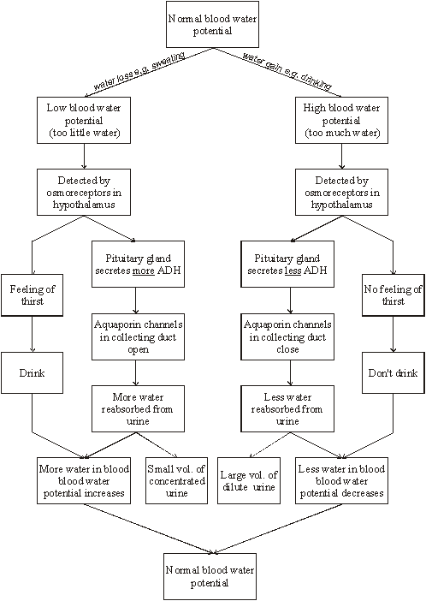

KIDNEY DISORDERS
Causes:
1. Hereditary factors due to gene deficiencies and mutations resulting in failure of transport of individual substances or groups of substances through the tubular membrane.
2. Damage to the tubular epithelial membrane by toxins.

COMMON KIDNEY DISORDERS
(a) Renal Glycosuria—Failure of the Kidneys to Reabsorb Glucose
In this condition, the blood glucose concentration may be normal, but the transport mechanism for tubular reabsorption of glucose is greatly limited or absent. Consequently, despite a normal blood glucose level, large amounts of glucose pass into the urine each day.

(b) Aminoaciduria—Failure of the Kidneys to Reabsorb Amino Acids

(c) Renal Hypophosphatemia—Failure of the Kidneys to Reabsorb Phosphate
In renal hypophosphatemia, the renal tubules fail to reabsorb large enough quantities of phosphate ions when the phosphate concentration of the body fluids falls very low. Over a long period, a low phosphate level causes diminished calcification of the bones, causing the person to develop rickets.

(d) Renal Tubular Acidosis—Failure of the Tubules to Secrete Hydrogen Ions
In this condition, the renal tubules are unable to secrete adequate amounts of hydrogen ions. As a result, large amounts of sodium bicarbonate are continually lost in the urine.

(e) Nephrogenic Diabetes Insipidus — Failure of the Kidneys to Respond to Antidiuretic Hormone
Occasionally, the renal tubules do not respond to antidiuretic hormone, causing large quantities of dilute urine to be excreted, which may cause dehydration.

(f) Fanconi’s Syndrome— Generalized Reabsorptive defect of the renal tubules
Fanconi’s syndrome is usually associated with increased urinary excretion of virtually all amino acids, glucose, and phosphate.
In severe cases, other manifestations are also observed, such as:
(i) Failure to reabsorb sodium bicarbonate, which results in metabolic acidosis;
(ii) Increased excretion of potassium and sometimes calcium;
(iii) Nephrogenic diabetes insipidus.

(g) Renal Failure
In this case, the kidneys simply cannot clear adequate quantities of salt due to loss of large numbers of whole nephrons, such as occurs with the loss of one kidney and part of another kidney.
Effects of renal failure can be minimised by Dialysis with an Artificial Kidney

HOMEOSTATIC ROLE OF THE LIVER AND PANCREAS
Structure of the liver:
The liver is the largest internal organ of the body, weighing about 1.5kg in humans, which is about 3.4% of the total body mass. The liver’s external shape is of little importance, but the internal structure reveals precious details.
Description of microscopic structure of the liver:
(Michael Roberts & Reiss, etal: Advanced Biology, 1st ed. 2000 Page 277) also see Fig.19.21 Taylor DJ etal: Biological science 3rd edition pg667
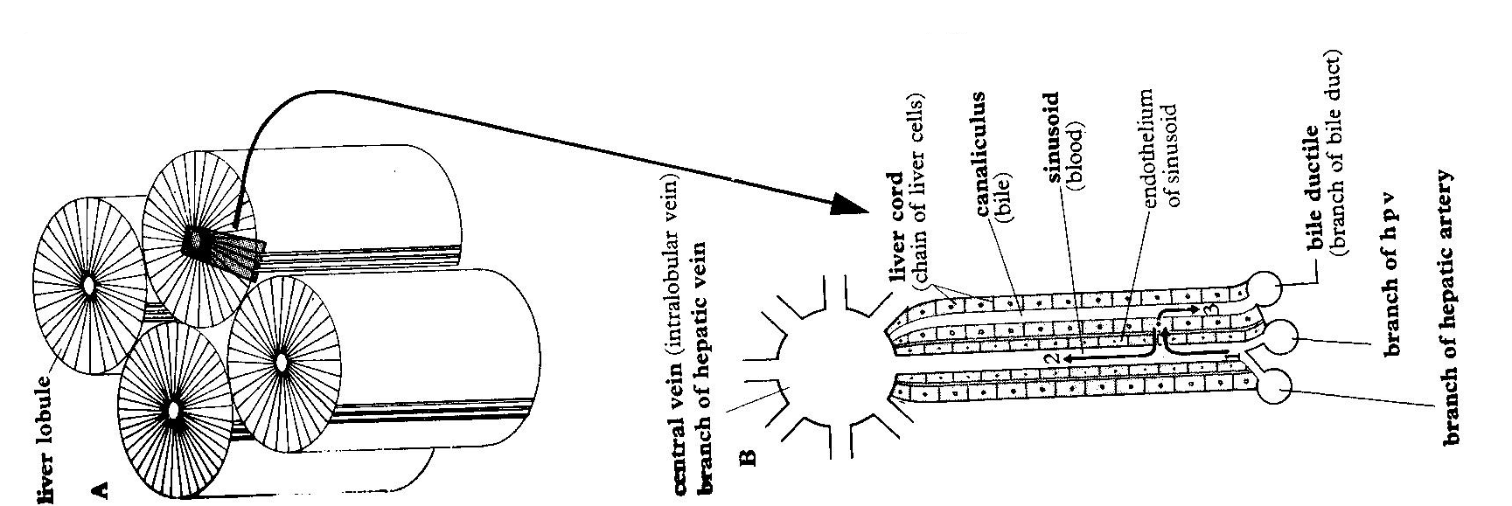

- The liver is composed of structural and functional units called lobules, which are cylindrically shaped, numbering over 100,000 and each approximating 1mm in diameter.
- Hepatocytes (liver cells) closely pack in each lobule in various rows radiating outwards from the centre.
- Hepatocytes (liver cells) are characterized by similarity in structure and function, prominent nuclei, Golgi complex and peroxisomes, numerous mitochondria, lysosomes, glycogen granules and fat droplets. Peroxisomes contain catalase and other oxidative enzymes responsible for detoxification. Hepatocytes which are in contact with blood vessels bear microvilli
- Located between lobules are triads consisting of a branch of hepatic artery which brings oxygenated blood to the liver, a branch of hepatic portal vein which brings nutrients from the gut and bile duct that drains bile from the liver.
- A central vein (branch of hepatic vein) runs longitudinally mid way each lobule and is linked by sinusoids to the interlobular vessels (hepatic artery and hepatic portal vein). Sinusoids radiate from the centre to the periphery of the lobule and their endothelial lining is perforated.
- Sinusoids alternate with bile canaliculi, small canals which carry bile.
- Attached to the walls of sinusoids are macrophagous cells called Kupffer cells.

How structure is related to function in the liver:
- Kupffer cells ingest worn out red blood cells, bacteria and foreign particles from the blood flowing through the liver.
- Closeness of hepatocytes (liver cells) with sinusoids and canaliculi enables them to receive nutrients and expel waste substances.
- The excellent blood supply provides nutrients to the cells and enables wastes to be carried away.
- Hepatocytes bear numerous mitochondria for ATP production required in providing energy that facilitates some of the metabolic reactions.
- Hepatocytes, which are in contact with blood vessels, bear microvilli to increase the surface area for exchange of substances.
- The liver is large, providing large surface area for metabolic reactions to occur.
- Hepatocytes bear numerous peroxisomes containing catalase and other oxidative enzymes responsible for detoxification of poisonous substances in the liver.
- Its tissue is elastic, enabling expansion to store large volume of blood
- Hepatocytes are similar in structure (undifferentiated) enabling them to perform various metabolic functions.

REGULATION OF BLOOD GLUCOSE
Interaction between the liver and pancreas enable the blood glucose level to be maintained at optimum concentration of 90 – 100mg of glucose per 100cm³ of blood (approximately 0.1% or 0.1g per 100cm³ of blood), inspite of the fluctuations of up to a high of 150 – 200mg per 100cm³ or lowering of up to 70mg per 100cm^{3.}

How the liver and pancreas interact to maintain glucose level constant
A rise in blood glucose level above the norm (known as hyperglycaemia) stimulates beta cells of the islets of langerhans in the pancreas to secrete the hormone insulin into blood.
Insulin binds to body cells with insulin receptors and causes processes which reduce glucose concentration, for example:
i) Increased cellular respiration in muscle and liver cells to form carbondioxide and water
ii) Increased glycogenesis (glycogen formation from glucose) in muscle and liver cells
iii) Increased conversion of glucose to fat and protein in adipose tissue
iv) Increased uptake of glucose in muscle cells.
A decrease in blood glucose level below the norm (known as hypoglycaemia) inhibits insulin secretion but stimulates alpha cells of the islets of langerhans in the pancreas to secrete the hormone glucagon into blood.
Being the only cells with glucagon receptors, glucagon binds to liver cells causing them to increase blood glucose level through:
i) Increased glycogenolysis (hydrolysis of glycogen to glucose).
ii) Increased formation of glucose from amino acids and glycerol. The formation of glucose from non-carbohydrate sources is called gluconeogenesis.

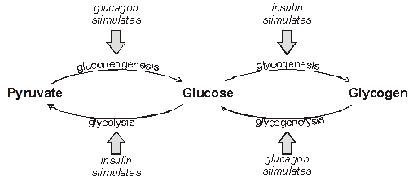

OTHER HORMONES THAT CONTROL BLOOD GLUCOSE CONCENTRATION
i) Adrenaline (from adrenal medulla) causes hydrolysis of glycogen to glucose during acute stress or excitement and the usage of glucose and thus increases and reduces its concentration in blood respectively.
ii) Cortisol (from adrenal cortex) causes formation of glucose from amino acids and glycerol when glycogen exhausts, hence increasing glucose concentration in blood.
iii) Growth hormone (from anterior pituitary) increases the glucose concentration in blood through fat breakdown.
iv) Thyroxine (from thyroid gland) stimulates metabolic rate e.g. increased glucose breakdown.

In some people there may be insufficient secretion of insulin or the cells may be insensitive to insulin, resulting in a condition known as diabetes mellitus.
Insulin dependent diabetes is caused by insufficient secretion of insulin while insulin independent diabetes results from insensitivity of cells to insulin.
Symptoms of diabetes mellitus: hyperglycaemia (high blood sugar), Glycosuria (glucose in urine), frequent copious urination, abnormal thirst, visual disturbances, itching of genitals, fatigue, rapid weight loss, drowsiness, skin disorders e.g. boils, general weakness.
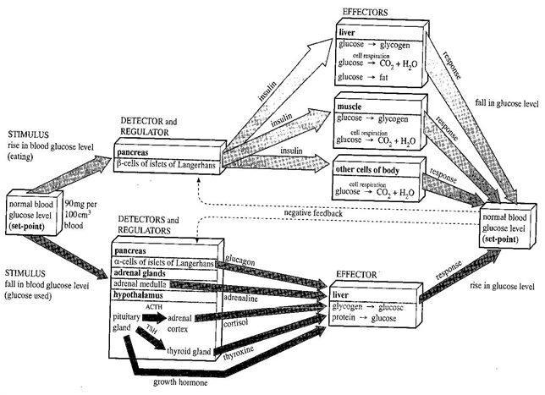

FUNCTIONS OF THE LIVER:
Some of the functions of the liver, out of the over 500 estimated it performs are digestive, regulatory, and excretory:
a) It maintains a steady blood glucose concentration by conversion of glucose to glycogen (if above the norm) and vice versa (if below the norm), under the influence of hormones. The liver’s carbohydrate metabolism involves the following: (Taylor DJ etal: Biological science 3rd edition pg666-671)
i) Glycogenesis, promoted by insulin
ii) Glycogenolysis, promoted by glucagon
iii) Lactic acid metabolism, initiated by the enzyme lactate dehydrogenase
iv) Gluconeogenesis, promoted by cortisone and adrenaline hormones
(Fig. 19.22Taylor DJ etal: Biological science 3rd edition pg668)

b) The liver regulates amino acids and proteins (is involved in protein metabolism) in the body:
i) Excess amino acids are not stored in the body, any surplus is gotten rid of by the liver through deamination process. This is involves removal of the amino group (-NH₂) from the amino acid to form ammonia, which in mammals is converted through a series of reactions (ornithine cycle) to urea [CO(NH₂)₂], which is shed from the liver cells into the blood stream and transported to the kidney for excretion. The amino acid residue (keto acid) is fed into the carbohydrate metabolism and oxidized to release energy, converted to glucose, glycogen or fat and stored.
ii) The liver also carries out transamination i.e. it transfers amino groups (-NH₂) from amino acids to other organic compounds to form amino acids that are deficient in the diet.
(Fig 4.7.3 Ann Fullick: Advanced Biology 200 edition page 331)also see (Fig 16.7and extension box Michael Roberts & Reiss, etal: Advanced Biology, 1st ed. 2000 Page 274)
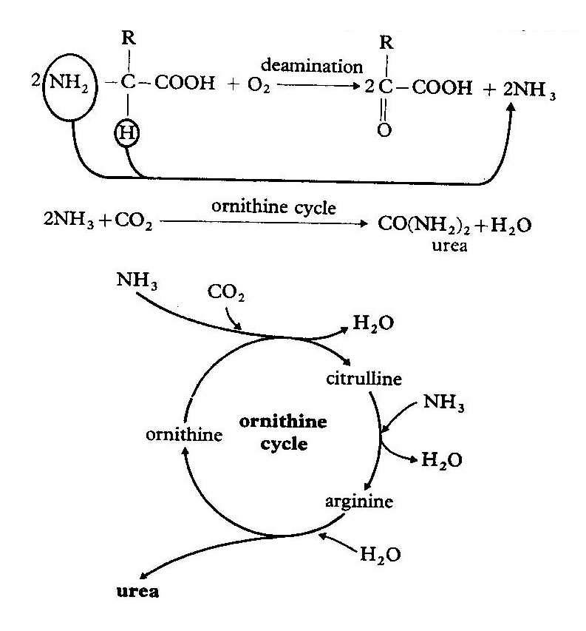
Summary of main reactions of the ornithine cycle
(i) The amino group (NH₂) of an amino acid is removed and reacts with hydrogen to form ammonia.
(ii) Ammonia reacts with carbondioxide to form carbamoyl phosphate, using energy from ATP.
(iii) The carbamoyl phosphate reacts with ornithine to form citrulline.
Reactions (ii) and (iii) occur in the mitrochondrial matrix).
(iv) Citrulline diffuses into the cytoplasm of liver cells and reacts with aspartate to form argininosuccinate.
(v) Argininosuccinate splits into arginine and fumarate. Fumarate can enter the krebs cycle.
(vi) Arginine is hydrolysed to form urea and ornithine.
(vii) Urea formed is carried by the blood stream to the kidneys for excretion in urine.

c) The liver regulates lipids (lipid metabolism) in the body:
i) Excess carbohydrate is converted to fat
ii) Stored fats are de-saturated prior to oxidation
iii) It synthesizes and degrades phospholipids and cholesterol
iv) It synthesizes lipid transporting globulins
Excess cholesterol in blood is excreted into bile by the liver to avoid their accumulation which can result in atherosclerosis (narrowing of arteries) which can cause thrombosis (blood clotting in blood vessels). If cholesterol is greatly in excess in bile, it forms gall stones, which can block the bile duct
d) The liver forms red blood cells and lymphocytes in foetus and breaks down worn out red blood cells in adults:
The liver’s kupffer cells break down worn out red blood cells to form the bile pigment bilirubin which is excreted in bile. The haemoglobin is broken down into globin, a protein and haem from which iron is removed and stored.
- The liver synthesizes plasma proteins from amino acids:
They include albumin (a transport molecule), globulin (a transport molecule of hormones), prothrombin and fibrinogen (clotting factors)
f) The liver produces bile, which is a mixture of salts and cholesterol
Bile emulsifies fats during digestion in the duodenum
g) The liver stores fat soluble vitamins A, D, E, K and water-soluble vitamins B₁₂ and C
h) The liver stores minerals like Iron, potassium, copper, zinc and trace elements.
i) The liver stores up to 1500cm³ of blood in its vast network of blood vessels, hence acting as a blood reservoir during emergency cases.
j) The liver destroys all hormones after exerting their effects in the body
k) The liver detoxifies poisonous substances i.e. naturally occurring compounds absorbed by the body, which can be toxic if allowed to accumulate are rendered harmless by the liver cells (hepatocytes) e.g. ethanol is oxidized to ethanal. Products of detoxification are usually excreted, but some times they are stored.

LIVER DISORDERS:
1. Jaundice – characterized by a yellowish tint to the white of eyes, lightly pigmented skin.
2. Hepatitis – liver inflammation, caused by hepatitis viruses A, B, C, D, E
3. Cirrhosis – liver becomes fatty, then fibrous. Common in alcoholics.
4. Liver cancer – caused by exposure to chemicals like cigarette smoke, radiations like X-rays or genetic pathways

THERMOREGULATION (TEMPERATURE REGULATION)

The necessity for thermoregulation:
- Most body enzymes act efficiently within a narrow temperature range of 35 – 38⁰C. Excessive temperature exceeding 45⁰C denatures enzymes and other proteins and below that range inactivates enzymes, both of which are fatal.
- Excessively high or too low temperature disorganizes the structure and functioning of cell surface membranes, and consequently affects entry and exit of substances resulting into death of the organism.

Terms associated with thermoregulation:

Term | Meaning | Example(s)
Endothermy | Ability of animals to maintain a constant body temperature. | Mammals and birds
Endotherm | An organism capable of maintaining a stable body temperature independent of the environmental temperature, by generating heat metabolically when environmental temperature is low. | Mammals and birds
Homeotherm  (Homoiotherm) | An organism capable of maintaining a stable body temperature independent of the environmental temperature | Mammals and birds
Poikilotherm | An animal with a body temperature that fluctuates with that of the external environment | Reptiles, fish, amphibians, insects, etc.  (all other animals except mammas and birds)
Ectotherm | Animal whose body temperature is regulated by behaviour or by the surroundings.
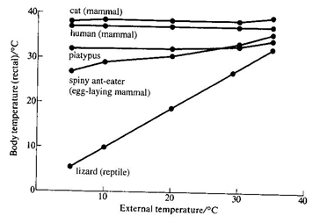
(Fig. 19.6Taylor DJ etal: Biological science 3rd edition pg653)

Heat gain and loss in organisms
Heat gain | Heat loss
- Heat is gained as a by-product of metabolism from exothermic reactions | - Heat is lost by the evaporation of water from body during sweating and from body surfaces like mouth and respiratory surface of land dwelling animals
- Heat may be gained from or lost to the environment by radiation. This is the transfer of energy in the form of electro magnetic waves.
- Heat may be gained from or lost to the environment by convection. This is the transfer of heat by currents in air or water.
- Heat may be gained from or lost to the environment by conduction. This is the transfer of heat by the collisions of molecules. Conduction is particularly important between organisms and the ground or water, since air does not conduct heat well.

Advantages and disadvantages of Endothermy
Advantages | Disadvantages
Animals are able to exploit various environments regardless of the existing temperatures. | There is high food intake during low environmental temperatures to support the metabolic reactions that liberate heat
Enzyme controlled reactions proceed without much interruption most of the time | Enzyme controlled reactions are slowed during low temperature because enzymes become inactive.
Since high metabolic reactions are maintained all the time, plenty of energy is availed to support body processes. | It requires efficient cooling mechanisms during hot temperatures to avoid overheating of the body, and efficient insulation when the external temperature is too low.

Advantage and disadvantages of Ectothermy
Advantages | Disadvantages
There is low food intake since regulation of temperature is by behavioural means and from the environment | Animals limited environments to exploit depending on the existing external temperatures
 | Their activities are limited during instances of extreme temperatures.
THE HUMAN SKIN
Figure 21.1 Phillips W. D and Chilton T. J, pg163AND Michael Roberts & Reiss, etal, P. 303-306 AND Toole Glenn and Susan: pg. 497 - 505
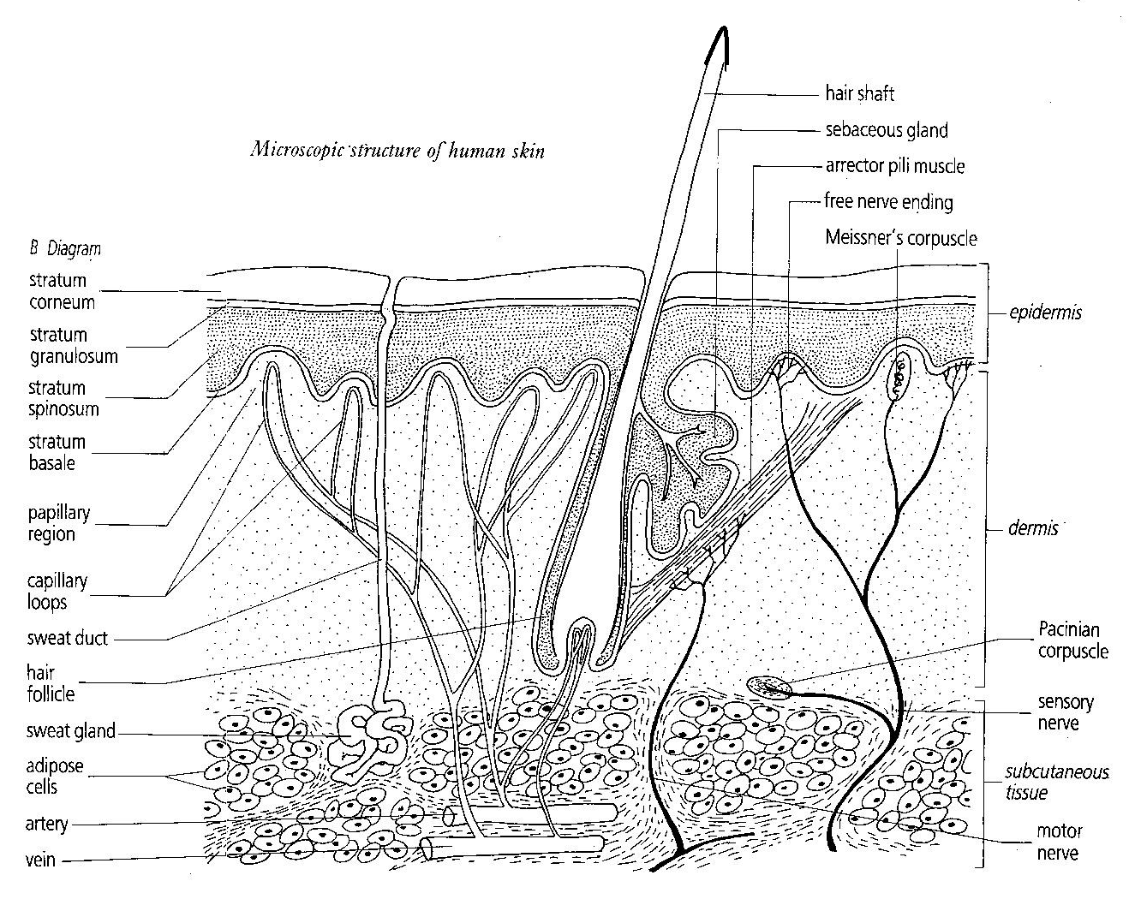

Functions of the skin:
i) It is the major organ involved in temperature regulation in the body.
ii) It provides protection against mechanical damage, ultra violet radiation from the sun, microorganism invasion and water loss of underlying tissues.
iii) It is a sense organ, containing sensory nerve endings for detecting temperature, touch, pressure and pain.
iv) It is an excretory organ of urea, salt and excess water.
v) It manufactures vitamin D when exposed to sun light. The dermis contains lipids called sterols which are converted by ultraviolet light into vitamin D.

Response of endotherms to variation of temperature in external environment
Response to hot conditions | Response to cold conditions
a) Physical and physiological means:  i) Vasodilation occurs i.e. superficial capillaries dilate to increase blood flow so that much heat can be lost by conduction and radiation.  ii) Sweat production by sweat glands increases to enable evaporation of heat from the skin surface.  iii) Panting occurs in birds, dogs to increase heat evaporation from the lungs, pharynx and other moist surfaces for body cooling.  iv) Erector pili muscles relax to lower hairs/fur, so that no insulating layer of air is trapped near the skin surface, enabling much heat loss  v) Metabolic rate reduces to minimise on the body heat generation.  b) Behavioural means (in man):  i) Taking cold drinks.  ii) Putting on light clothing.  iii) Moving to shady places.  iv) Taking a bath.  v) Being active mainly at night (nocturnability) | a) Physical and physiological means:  i) Vasoconstriction occurs i.e. superficial capillaries narrow to reduce blood flow so that heat loss by conduction and radiation can be minimised.  ii) Sweat production by sweat glands reduces/stops to reduce evaporation of heat from the skin surface.  iii) Erector pili muscles contract to cause hairs/fur to ‘stand on end’ to trap an insulating layer of air near the skin to reduce heat loss by convection.  iv) Metabolic rate increases to generate extra heat in the body. This occurs particularly in muscle and liver cells. Special brown fat may also be metabolized.  v) Shivering, which the involuntary contractions of the skeletal muscles occurs so as to generate heat metabolically.  b) Behavioural means (in man):  i) Taking hot drinks.  ii) Putting on thick clothing.  iii) Moving near fire / heat sources.  iv) Turning on heat in houses.

(Fig 2 Kent Michael: Advanced Biology, 1st ed. 2000 Page 154)
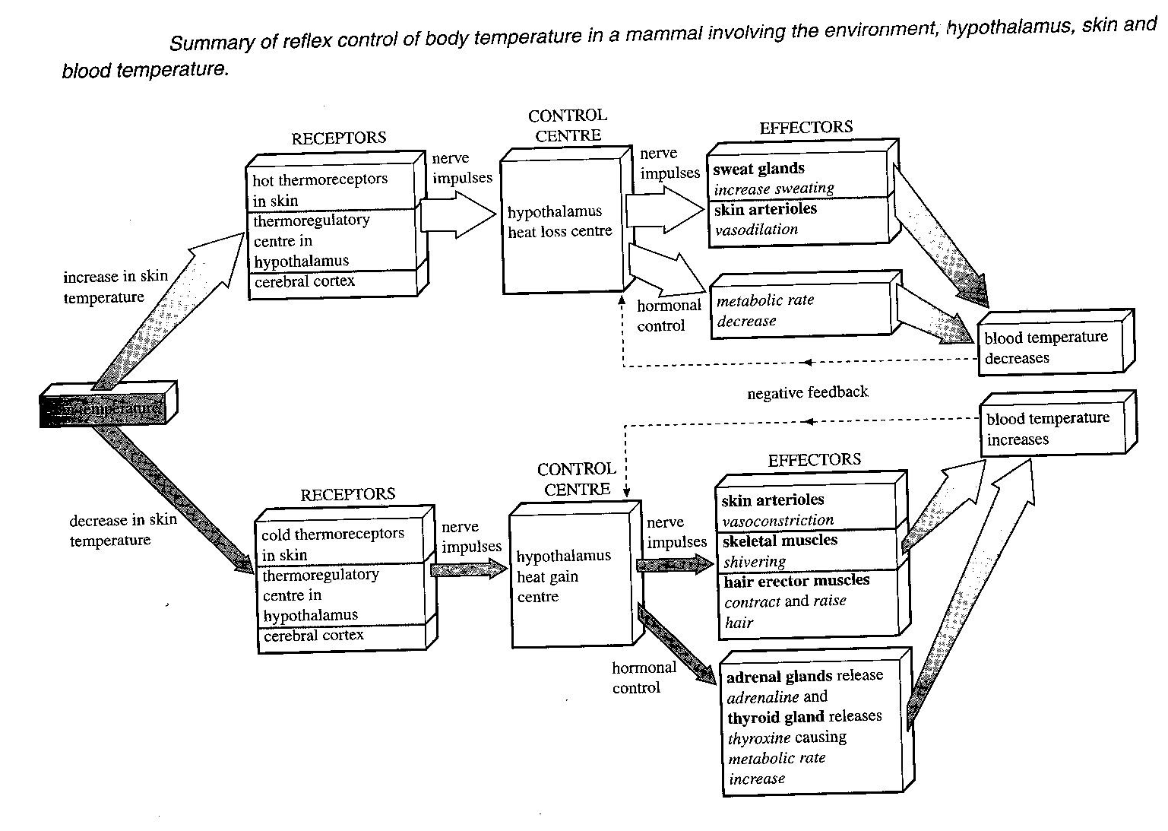

PHYSIOLOGICAL RESPONSES TO VARYING ENVIRONMENTAL TEMPERATURE
Two separate groups of naked people, one is exposed to gradually cooling air while another to gradually increasing air temperature. Their metabolic rates, physical changes and internal core body temperature are observed.
Why naked people? To avoid physical interference of clothes or coverings such that observations made are based purely on physiological responses of the body.

Figure 15.6 Roberts MBV: Biology a functional approach, 4th ed. Page 238 AND FIG 15.3 PG 236
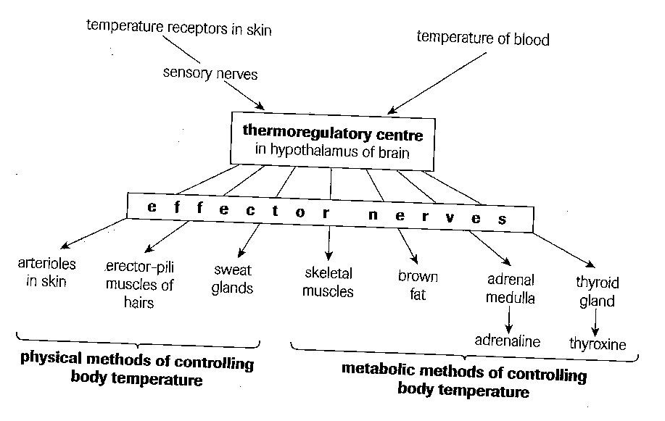
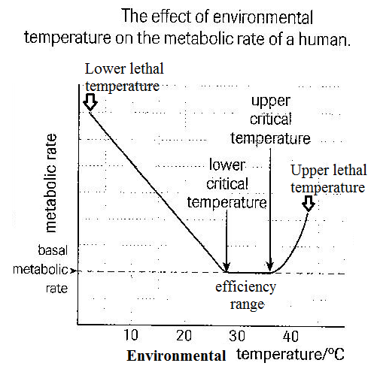

1. Low critical temperature:
This is low environmental temperature at which physical mechanisms like vasoconstriction and erection of hair fail to maintain body temperature constant, triggering a rise in metabolic rate to generate heat to maintain body temperature constant.
2. Lower lethal temperature:
This is extremely low environmental temperature at which increased metabolic rate fails to generate enough heat to maintain body temperature constant, resulting into death of the organism.
Hypothermia is the condition that results when heat loss greatly exceeds heat gain from metabolism due to prolonged exposure to cold, resulting into great reduction in core body temperature of the organism.
3. High critical temperature:
This is high environmental temperature at which physical mechanisms like sweating and vasodilation fail to maintain body temperature constant, triggering a rise in metabolic rate and body temperature as environmental temperature rises.
4. Upper lethal temperature:
This is an extremely high environmental temperature at which increased metabolic rate generates excessive heat which denatures enzymes and other structures, resulting into death of the organism.
5. Efficiency range (Range of thermo neutrality):
This is external temperature range at which the body’s physical mechanisms are capable of maintaining temperature constant. In man this is 27 – 31⁰C.

Efficiency range varies according to the environmental temperature in which the animal inhabits. This is because animals have the ability to acclimatize. If the environmental temperature is high, acclimatization is by raising the upper critical temperature and if low, acclimatization is by lowering lower critical temperature.

Figure 18.7 Michael Roberts & Reiss, etal, 1st ed. 2000 Page 311 also see Figure 15.7 Roberts MBV: 4th ed. Page 239
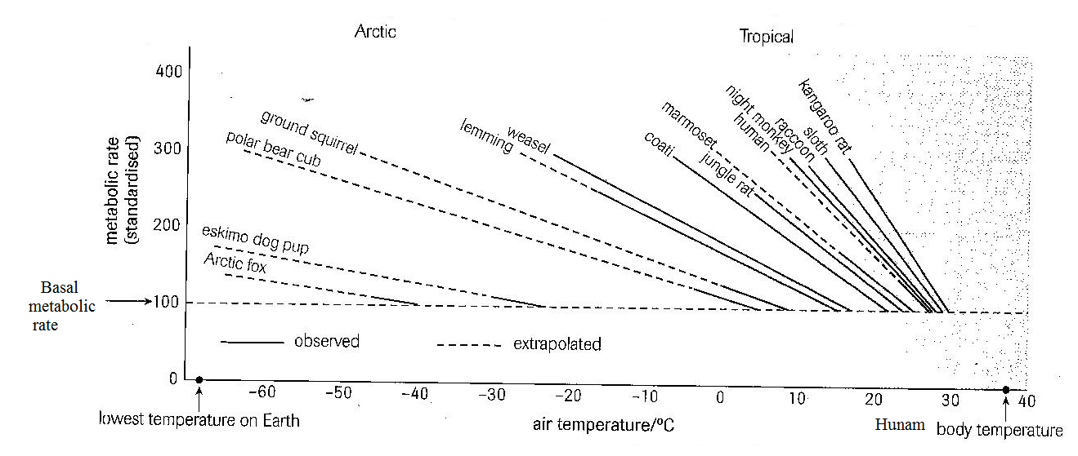

Observations from the graph:
- The low critical temperature for animals living in cold places is much lower than for those, which live in warm places. E.g. the desert kangaroo rat Dipodomys has a low critical temperature just below 30⁰C, whereas the Arctic fox’s is about -40⁰C.
- The lower lethal temperature is much lower for cold-dwellers than for warm-dwellers.
- Below the low critical temperature, the metabolic rate of warm-dwellers rises more sharply than in cold-dwellers.
d) The metabolic rate starts to rise at a much lower critical temperature for cold-dwellers that for warm-dwellers.

ADAPTATIONS TO EXTREME CLIMATES
Adaptations to life at low temperatures | Adaptations to life at high temperatures
a) Structural adaptations:  - Possession of thick fur/hair for trap ing a layer of air that is warmed and remains insulating the body against heat loss e.g. polar bears.  - Possession of thick layer of subcutaneous fat for insulation against heat loss e.g. polar bears and seals.  - Development of larger body size than their counterparts in warmer climates to reduce surface area to volume ratio in order to reduce heat loss. E.g. whales, polar bears. This is termed Bergman’s rule.  - Extremities such as ear lobes are of reduced size than related species in warmer climates to reduce surface area for heat loss. This is termed Allen’s rule.  b) Other adaptations:  - Development of countercurrent heat exchange systems in limbs to enable heat conservation. By minimizing its loss to the environment. E.g. in duck’s legs, dolphin’s flippers.  Countercurrent heat exchange system is heat conservation in limbs where there is effective heat transfer at all levels to the periphery of the limb, by conduction from the incoming warmer arterial blood to the outgoing colder venous blood.  - Small sized animals hibernate e.g. bats, dormice, hamsters, hedgehogs, and rodents like mice.  Hibernation is seasonal response by animals to cold temperature during which they become dormant, body temperature and metabolic rate fall to the minimum required for maintaining the vital activities of the body. The animals, said to be in ‘deep sleep’ ably reduce energy needs to survive the winter when food is scarce.  Brown fat is conserved and used up rapidly at the end of hibernation to quickly raise the metabolic heat  - Some animals migrate to warmer places e.g. birds like swallows | a) Structural adaptations:  - Development of smaller body size than their counterparts in colder climates to increase surface area to volume ratio in order to increase heat loss.  - Extremities such as ear lobes are large, thin with rich blood supply to enable heat loss more easily e.g. elephant’s ears.  - Having tissues that are tolerant to large temperature fluctuations between day and night e.g. the camel  - Bodies are thinly insulated with fat to increase heat loss.  b) Other adaptation:  Some animals aestivate. Aestivation is seasonal response by animals to drought or excessive heat during which they become dormant, and the metabolic rate together with body temperature reduce to the minimum required for maintaining the vital activities of the body.  E.g. African lungfish burrows into mud till the dry season ends, earthworms and garden snails also aestivate.
Brown fat is a special type of heat producing fatty tissue which owes its colour to the numerous mitochondria it contains. The mitochondria generate heat rather than ATP. Animals moving out of hibernation break it down and it generates heat more quickly than ordinary fat since it has a good blood and nerve supply

Figure 18.10 Michael Roberts & Reiss, etal: Advanced Biology, 1st ed. 2000 Page 312 AND Figure 21.6 Phillips W. D and Chilton T. J : A-level Biology, revised ed.pg167
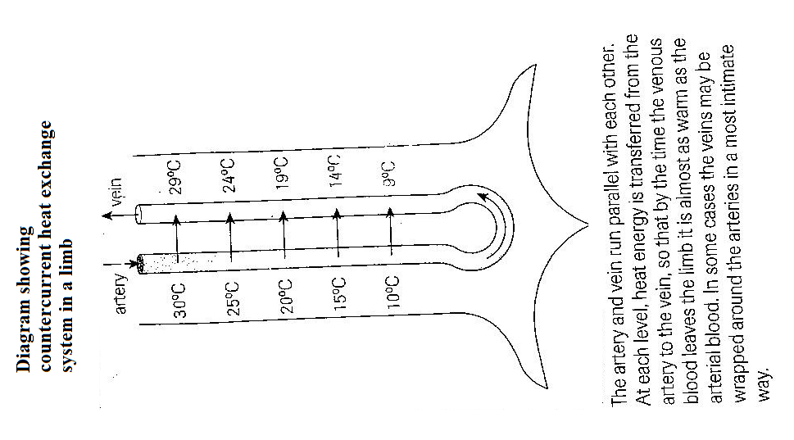

Two mammals were exposed to varying air temperatures, and each time the temperatures were varied, various metabolic rates were determined, and the results of the findings tabulated.

Environmental temperature / ⁰C |  | -20 | -15 | -10 | -5 | 0 | 5 | 10 | 15 | 20 | 25 | 30 | 35 | 40 | 45 | 50
Relative metabolic rate | Mammal A | 4.0 | 3.5 | 3.1 | 2.6 | 2.2 | 1.8 | 1.0 | 1.0 | 1.0 | 1.0 | 1.0 | 1.0 | 1.0 | 1.1 | 1.2
Relative metabolic rate | Mammal B |  |  |  |  |  | 5.0 | 4.0 | 3.0 | 2.0 | 1.1 | 1.1 | 1.1 | 1.1 | 1.2 | 1.3

a) Plot suitable graphs to show these relationships.
b) Describe each of the graphs you have plotted.
c) Explain the observed patterns of relationships.
d) Why did the experiment fail to determine the relative metabolic rate of mammal B for temperatures above 50⁰C and below 5⁰C?
e) Assuming that mammals A and B show very close evolutionary relationships, distinguish between their relative sizes and show how they are related to their survival strategies in different environmental conditions

TEMPERATURE CONTROL IN ECTOTHERMS
This is mainly achieved through modification of behaviour of the organism, which may include:
- Basking in the sun, at varying angles relative to the sun’s rays so as to gain heat e.g. lizards and crocodiles.
- Hiding in burrows, holes or crevices in rocks away from sunlight reduces temperature e.g. lizards.
- Panting and exposing the moist tissues of the mouth, by licking the body surface or by swallowing in water an animal can increase evaporation and so heat loss from the body.
- Thermal gaping, opening the mouth to enable evaporation of moisture from the buccal cavity to cool blood e.g. alligators.
- Thermal dancing when it is hot i.e. lifting of opposite pairs of feet alternately so that they can cool in air e.g. shovel-snout lizards.
- Salivation over the neck and legs in tortoises to increase loss of heat as a result of water evaporating from such surfaces.

ROLE OF THE BRAIN IN TEMPERATURE REGULATION
The thermoregulatory centre in the hypothalamus of the brain is responsible for temperature regulation in the body.
- Variation in body temperature is directly monitored by heat receptors in the hypothalamus and indirectly by receptors in the skin. Receptors in the skin monitor variation of external temperature.
- If the temperature of blood flowing through the hypothalamus drops, the heat gain centre is stimulated to send impulses to the liver and muscles to raise metabolic rate so as to generate heat, and to the skin to cause vasoconstriction to reduce heat loss at the skin surface, reduction in sweat production, contraction of erector pili muscle and shivering. The overall result is increased body temperature to normal.
- If the temperature of blood flowing through the hypothalamus rises, the heat loss centre is stimulated to send impulses to the skin to cause vasodilation to enable more heat loss at the skin surface, increased sweat production to enable more evaporation, relaxation of erector pili muscles to lower the hairs to avoid air insulation, and to inhibit shivering to minimise heat production by metabolic reactions. All these enable lowering of temperature to normal.
- Variation in external temperature stimulates receptors in the skin to send impulses to the brain and the animal’s behaviour is modified accordingly e.g. if the skin heats up, the animal may move to the shade, while cooling of the skin surface may give rise to increased metabolic activity.

TEMPERATURE CONTROL IN PLANTS
Plants lose and gain heat by the same physical processes as animals – radiation, evaporation, conduction, and convection.
Plant tissues can tolerate wide fluctuation in temperature and are adapted to live in a variety of habitats, but still they must regulate temperature to avoid overheating which would denature enzymes, and freezing of tissues which would slow down metabolic processes.

Plants avoid overheating by:
i) Transpiration – as the water evaporates into the atmosphere, plant bodies cool down.
ii) Wilting – parenchyma cells lose turgidity and drop to reduce the surface area of leaves and stems exposed to the sun, hence avoiding much heat gain.
iii) Possession of shiny cuticle on leaves to reflect heat (sun’s radiation) and avoid overheating.
iv) Possession of small needle-like leaves in some plants also reduces excessive heat gain from the sun’s rays.

Plants avoid overcooling by:
i) Producing spores or seeds, which are very temperature resistant.
ii) Losing the easily damaged leaves when external temperature is low e.g. during winter in temperate plants.
iii) Orientating leaves to take maximum advantage of light at any one time so that they do not shade each other

