1.3.4: Assessing Risks
From the ball tossing game you can note that:
- Low risks or very minimal risks e.g. choosing position (one in the third round) whereby the reward is similarly minimal.
- Moderate risks e.g. choosing positions (four and five) where the chance of gaining is almost half just like that of losing.
- High Risks e.g. choosing positions beyond ten where the chance of losing is much higher than that of gaining.

Entrepreneurs should not risk more than they can afford to lose. Success will be easier to achieve if one is willing to and is able to take the necessary and calculated risks. The outcome of taking a risk is normally not known but it must be evaluated. It involves potential success and potential loss; the greater the possible loss, the greater the risk involved. Risks can be assessed basing on the following factors:
- Experience and abilities of the person or persons involved in the business .ie. its adequacy leads to success while inadequacy leads to losses.
- Viability of the business idea .ie. how profitable the business opportunity is.
- Availability of a market. Big Market size for products leads to business success while limited market leads to failure.
- Pricing policies and strategies. Setting competitive prices and offering credit to trust worthy customers leads to profit s hence successful business while very high profits chase away customers and very low prices lead to losses.
▪ Cash flow; capital requirement.ie. Movement of cash in
and out of the business. Hence more cash inflow leads
to business success while more cash outflows lead to
business failure.
- Flexibility of the business. Ie. Change from one line of business to another. For example, change products, change technology, marketing strategies etc lead to successful business while the rigid and nonflexible will lead to losses.
- Honesty and reliability of the entrepreneur. A higher degree of honesty and reliability by people dealing with the business (workers, customers and suppliers) the higher the chances of business success while the dishonest and the unreliable they are the higher the chances of losses incurred.

1.3.5: Risk Management in Business
Business is all about risk taking and management and therefore, one should not fear taking it, but should rather assess and weigh the kind of risk to take.

Methods of minimizing Risks.
Risks can be minimized using the following methods: 16
Risk avoidance | These are measures that can help to prevent the risk from occurring. For example, a driver should not drink and drive.
Risk reduction | This is the taking of measures to minimize the likely loss or chances of the risk happening. For example putting in place fire extinguishers or having a standby generator.
Risk transfer | This is when the burden of taking responsibility of a risk is shifted to another party. For example taking an insurance policy against fire, accident, and theft.

Activity 1.3.3
In your notebooks:
- make a list of any 4 possible risks in your school.
- explain the strategies/ways that can be undertaken by the school to minimize the risks.
- hand in your books for marking.

a-Make a list of any four possible risks in your school.
- -----------------------------------------------------------------------------
- -------------------------------------------------------------------------------------
- ------------------------------------------------------------------------------
- ------------------------------------------------------------------------------

b- Give Strategies that can be used or undertaken by the
school to minimize the risks.
- ---------------------------------------------------------------------------
- ---------------------------------------------------------------------------
- ---------------------------------------------------------------------------
- ---------------------------------------------------------------------------
Possible ways of Minimizing Risks In Business
These include the following:-
1-Employing well skilled and experienced workers to
produce quality products.
2-Using modern and reliable technology.
3-Observing Govt laws and regulations . For example, paying taxes so as to prevent business closure.
4- Employing security measures such employing well armed and trained security guards, having a wall fence, burglar proof windows and doors, security light etc.
5- Installing fire/smoke detectors within business premises so as to detect fire out breaks and minimize its effect.
6- Keeping regular track of customers tastes and preferences.
7- Minimizing credit sales so as to reduce bad debts.
8- Effectively monitoring and supervising all business activities so as to minimize mistakes during the production process.
9- Conducting regular research on better and new methods of minimizing business risks.
10- Insuring the business.
11- Training workers on how to use new machinery or handle modern technology.
12- Improving the quality of business products and customer care services.
13- Proper record keeping to ensure proper financial management to reduce embezzlement of company funds by workers.
14- Locating reliable sources of raw materials and having many suppliers of these raw materials.
15- Maintaining good working relationship between the workers and employer at the work place so as to reduce strikes.
ACTIVITY:
Write a story a bout a business owner in your community who suffered a loss caused by un expected risks.
(use space provided below)
----------------------------------------------------------------------------------------------------------------------------------------------------------------------------------------------------------------------------------------------------------------------------------------------------------------------------------------------------------------------------------------------------------------------------------------------------------------------------------------------------------------------------------------------------------------------------------------------------------------------------------------------------------------------------------------------------------------------------------------------------------------------------------------------------------------------------------------------------------------------------------------------------------------------------------------------------------------------------------------------------------------------------------------------------------------------------------------------------------------------------------------------------------------------------------------------------------------------------------------------------------------------------------------------------------------------------------------------------------------------------------------------------------------------------------------------------------------------------------------------------------------------------------------------------------------------------------------------------------------------------------------------------------------------------------------------------------------------------------------------------------------------------------------------------------------------------------------------------

Conclusion

As it was mentioned in the introduction, doing business is taking a risk. As an entrepreneur you should not fear taking risks, but rather assess, weigh and calculate the risks involved in the business you want to operate before you start.

1.4: Technology and Business
Key words  - e-business  - technology  - networking  - Internet  - Facebook | By the end of this topic, you should be able to practice doing e-business and teach your community to do the same.

17
The way people do business has been changing drastically for the last ten years. Business can be transacted using many safe, convenient and very fast means. You no longer have to move across nations to purchase commodities. It can be done using modern technological tools and software.

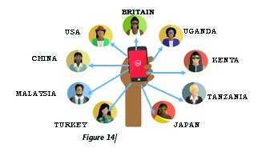

Figure 14 illustrates that it is possible to connect with people in different countries using a mobile phone. This is e-business.

1.4.1: Meaning of e-business
This is the type of business carried out using modern technology. Examples of e-business include the following:

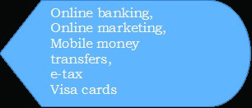
Fill the above examples of e-business to the corresponding definitions provided in the table below;
18
Is where you are able to transfer money from one account to another on your mobile phone or computer.
This is the use of you mobile phone to send money to another person or receive money from another person.
Is a modern process of paying taxes to Uganda revenue authority (URA) Using your telephone or computer.
This is a modern teaching method which involves the use of electronic technologies to access educational curriculum outside a traditional classroom. These include radios, televisions, computers, and mobile phones.
This is the process of advertising , pricing and distribution of goods and services using computers and mobile phones.
These are cards issued by financial institutions to their clients to enable them access goods or services and other properties easily without necessarily visiting their bank accounts. For example ATV cards, Uber and safe BODA Transport services.

1.4.2: Doing e-business
Entrepreneurs can use e-business/online business to meet customers’ orders, effect payments for utilities (such as water, TV, electricity bills and buy airtime or bundles), business registration, paying taxes and any other online business transactions.

The above e-business services enable the entrepreneur work within a given timeframe and effectively satisfy the needs of customers at a low cost and in a more efficient way.

Therefore a business can minimize production costs by engaging in online/e-business activities and remain competitive on the market.

Figure 8: Online banking | 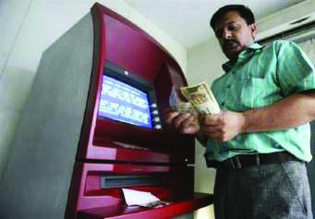  Figure 9: Entrepreneur using an  ATM

Activity 1.4.1
Visit selected businesses in your community and find out the following:
- e – Business services used by the entrepreneur.
- How e-business benefits the entrepreneur.
- The challenges faced by the entrepreneur while using online business / e-business.
Write a report of one page in your notebook giving your findings.
(Summarize your report in the space provided below)

- E-business services used by the entrepreneur in your community .
These include the following:-
I)------------------------------------------------------------------------------
ii)-----------------------------------------------------------------------------
iii)----------------------------------------------------------------------------
iv)----------------------------------------------------------------------------
v)-----------------------------------------------------------------------------
b) How has e-business benefitted the entrepreneur in your community.
i)--------------------------------------------------------------------------------------------------------------------------------------------------------------------------
ii)------------------------------------------------------------------------------------------------------------------------------------------------------------------------------
iii)-----------------------------------------------------------------------------------------------------------------------------------------------------------------------------
iv)-----------------------------------------------------------------------------------------------------------------------------------------------------------------------------
v)-----------------------------------------------------------------------------------------------------------------------------------------------------------------------------------------------------------------------------------------------------
vi)------------------------------------------------------------------------------------------------------------------------------------------------------------------------------------------------------------------------------------------------------------------------------------------
c-What challenges were faced by the entrepreneur in your community while using e-business.
- -----------------------------------------------------------------------------------------------------------------------------------------------
- ----------------------------------------------------------------------------------------------------------------------------------------------------
- ------------------------------------------------------------------------------------------------------------------------------------------------------
- ----------------------------------------------------------------------------------------------------------------------------------------------------
- ------------------------------------------------------------------------------------------------------------------------------------------------------
- ------------------------------------------------------------------------------------------------------------------------------------------------------
19

1.4.3: Benefits /Advantages of e-business to the entrepreneur
E-Business brings a lot of benefits to an entrepreneur. Some of them include the following:
- It enables the entrepreneur save transport costs while transacting business.
- It is convenient since entrepreneurs do not have to move with large sums of money to transact business. This saves him the dangers of robbery.
- It is a very fast method of effecting payments irrespective of the geographical location of the receiver and the sender.
- The entrepreneur can easily advertise his/her products across the world using online marketing.
- The entrepreneur can easily order for raw materials or purchase goods from foreign countries without going there physically.

1.4.4: Challenges of using e-business
Although e-business has a number of advantages to the entrepreneur, it also has some challenges. These include:

- A challenge of poor network. In areas where the network is poor or non-existent, e-business may not take place.
- Limited knowledge on how to use e- business services. If an entrepreneur does not know how to use e-business, it becomes a big challenge to him/her to transact business.
- Limited access to the mobile phones, laptops, computers to effect online transactions makes e-business complicated.
- High level of fraud by conmen which leads to financial losses to the entrepreneur.
- High costs for effecting the online transactions e.g. Withdrawal charges, operation charges, taxes.
- Inadequate power supply especially in rural areas makes using e- business difficult.

20

Activity of Integration
Read the case study below and answer the questions which follow.

KATO’S MODERN FURNITURE WORKSHOP
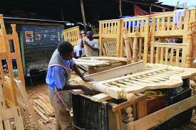
Kato made some savings from selling his inherited piece of land and invested it in a carpentry business. He has operated a carpentry business for five years and has a target of becoming the leading producer and seller of quality furniture products in his community. Kato wakes up early to do different activities in his business although things have not been easy for him since initially he had few customers.

Last year Kato received a big order from a nearby school which requested him to supply fifty dining tables within one month; he fulfilled this order in time and was able to get more orders from the community members. Kato received another order from a distant school of 100 desks. He bought modern machines which enabled him to add creative and innovative fashions in his business. Work became faster and the quality of his furniture improved; in two weeks, Kato was able to finish and deliver the desks.

Since the number of orders had increased, Kato employed two more people who were qualified and skilled in carpentry. He went for further training in modern carpentry designing. He also uses the Internet to
21
access these designs, and this has made him more competent in his business. Kato is using the knowledge and skills he acquired to make furniture with modern designs which has further attracted more customers and increased his profit margin. He has a plan of opening another branch in another nearby community.

QUESTIONS
- Identify the problems which Kato was able to solve in his community.
These include the following;
a. )------------------------------------------------------------------------------------------------------------------------------------------------------------------
b.)---------------------------------------------------------------------------------------------------------------------------------------------------------------
c)-----------------------------------------------------------------------------------------------------------------------------------------------------------------
d)-------------------------------------------------------------------------------------------------------------------------------------------------------------------
e)-----------------------------------------------------------------------------------------------------------------------------------------------------------------

- State any four qualities which have enabled Kato to become a successful carpenter.
a)------------------------------------------------------------------------------------------------------------------------------------------------------------
b)------------------------------------------------------------------------------------------------------------------------------------------------------------------
c)-----------------------------------------------------------------------------------------------------------------------------------------------------------------
d)---------------------------------------------------------------------------------------------------------------------------------------------------------------

- What possible risks does Kato face in his business and how can they be managed?

- Possible risks include;
i)--------------------------------------------------------------------------------
ii)---------------------------------------------------------------------------------
iii)--------------------------------------------------------------------------------
iv)--------------------------------------------------------------------------------
v)---------------------------------------------------------------------------------
vi)--------------------------------------------------------------------------------
vii)-------------------------------------------------------------------------------
viii)------------------------------------------------------------------------------
ix)-------------------------------------------------------------------------------
x)--------------------------------------------------------------------------------

b) How the above risks can be managed.
These can be managed in the following ways;
i)-------------------------------------------------------------------------------------------------------------------------------------------
ii)------------------------------------------------------------------------------------
iii)-----------------------------------------------------------------------------------
iv)-----------------------------------------------------------------------------------
v)----------------------------------------------------------------------------------
vi) -----------------------------------------------------------------------------------
vii) -----------------------------------------------------------------------------------
viii) ----------------------------------------------------------------------------------
ix) ------------------------------------------------------------------------------------
x) ------------------------------------------------------------------------------------

- How did Kato employ creativity and innovation in his business?

- He employed CREATIVITY in the following ways;
- ----------------------------------------------------------------------------------------------------------------------------------------------
- ----------------------------------------------------------------------------------------------------------------------------------------------
- --------------------------------------------------------------------------------------------------------------------------------------------
- ------------------------------------------------------------------------------------------------------------------------------
- ---------------------------------------------------------------------------------------------------------------------------------------------

- He employed INNOVATION in the following ways;
- ---------------------------------------------------------------------------------------------------------------------------------------------
- ---------------------------------------------------------------------------------------------------------------------------------------------
- ----------------------------------------------------------------------------------------------------------------------------------------------
- ----------------------------------------------------------------------------------------------------------------------------------------------
- ----------------------------------------------------------------------------------------------------------------------------------------------

- Advise Kato on how he can use modern technology to improve his business.
----------------------------------------------------------------------------------------------------------------------------------------------------------------------------------------------------------------------------------------------------------------------------------------------------------------------------------------------------------------------------------------------------------------------------------------------------------------------------------------------------------------------------------------------------------------------------------------------------------------------------------------------------------------------------------------------------------------------------------------------------------------------------------------------------------------------------------------------

Chapter Summary
In this chapter you have learned the following:
- The qualities that enable entrepreneurs to be successful in their businesses.
- How entrepreneurs can minimize risks in their businesses.
- How entrepreneurs use creativity and innovations to produce new and unique products from local materials.
- The benefits of being an entrepreneur.

22

CHAPTER 2

BUSINESSES IN UGANDA
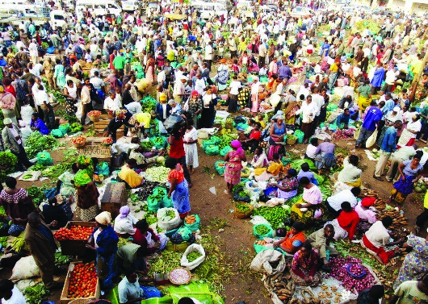 | 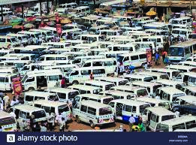
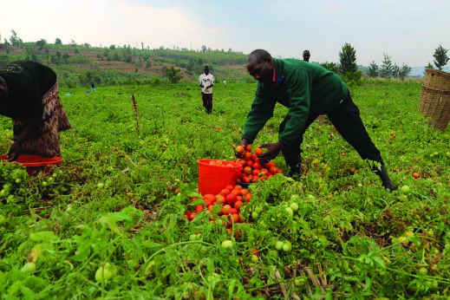 | 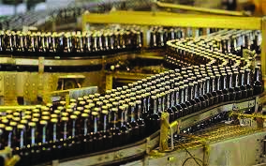

Key Words | By the end of this topic, you should be able to:
- business  - agro-business  - manufacturing business  - trading business  - service business | - identify different types of business in Uganda  - evaluate the importance of doing business  - determine the factors leading to success in business and what causes failure in business.

23

INTRODUCTION
In Uganda entrepreneurs carryout different types of business; the primary objective for doing business is to make profit. In order to achieve this objective entrepreneurs should make sure they succeed in their business and avoid business failure.
Before starting a business the entrepreneur should come up with many good business ideas but select one business opportunity basing on the available resources and carryout a market survey for the business. After doing all this, the entrepreneur can now prepare to start the business.

2.1: Types of Businesses

2.1.1: Meaning of Business
Business is any legal economic activity done by an individual or a group of persons with an aim of making profits. Examples of business include buying and selling agricultural produce, running a retail shop, operating a restaurant, providing services like salons, growing vegetables, etc.
Business involves exchanging goods or services for money with a view of earning profits while bearing risks since risks and business are almost inseparable.

Activity 2.1.1
Conduct a field study and establish the different types of businesses carried out in your community.

Name them in space provided below;
- ---------------------------------------------------------

- ----------------------------------------------------------
- ----------------------------------------------------------
- ----------------------------------------------------------
- ---------------------------------------------------------
24

2.1.2: Types of Business
There are four types of businesses; Agro-businesses, manufacturing businesses, trading businesses and service businesses.
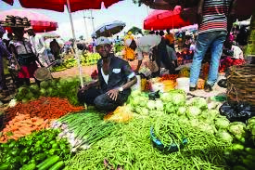
Figure 17 Figure 18
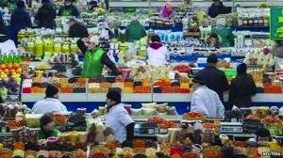 | 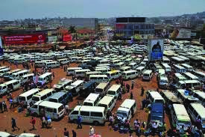
Figure 19 Figure 20

Activity 2.1.2
Study the figures above and answer the questions below in your exercise book:
- Explain the type of business that is taking place in figure 17?

--------------------------------------------------------------------------------------------------------------------------------------------------------------------------------------------------------------------------------------------------------------------------------------------------------------------------------------------------------------------------
- Explain the type of business that is taking place in figure 18?
--------------------------------------------------------------------------------------------------------------------------------------------------------------------------------------------------------------------------------------------------------------------------------------------------------------------------------------------------------------------------
- Explain the type of business that is taking place in figure 19?
----------------------------------------------------------------------------------------------------------------------------------------------------------------------------------------------------------------------------------------------------------------------------------------------------------------------------------------------------------------------------
- Explain the type of business that is taking place in figure 20?
--------------------------------------------------------------------------------------------------------------------------------------------------------------------------------------------------------------------------------------------------------------------------------------------------------------------

Agri-businesses
Agri-businesses produce or sell agricultural products with the aim of making profit. They include the following;
- Crop production; these are businesses engaged in the production and selling of crops like maize, bananas, coffee, tomatoes, millet cassava and many others.
- Livestock production; these’re businesses engaged in the production and selling of different animals like cattle, goats, rabbits, pigs and many others.
- Poultry keeping; this is a type which concentrates in the rearing and selling of different birds such as chicken, turkeys, and ducks for their meat and eggs.

5

Manufacturing Businesses
These are businesses that process raw materials into semi-finished or finished products by adding value to them. manufacturing businesses provide a wide range of job opportunities depending on what they produce. Examples of such businesses include the following;
- Metal fabrication businesses like makers of metal doors, windows, furniture, bicycles etc.
- Carpentry and joinery, involved in making of furniture for sale and construction work.
- Agro-processing businesses; these are businesses which transform agricultural raw materials into different final agricultural products such as cooking oil , juices maize, soya, rice flour and many others.
- Extractive manufacturing businesses; these are businesses which extract materials such as clay, grass, papyrus, stones, etc. and transform them into different semi-finished and finished products baskets, bricks, brickets or tiles.

Trading Businesses
Trade is the activity that involves the buying and selling of goods and services between people. It may take place between nations or within the same country.
Trading businesses are carried out by either retailers or wholesalers. Many of them are found in your communities.
- Wholesale trade: The business buys goods in large amounts like in boxes, cartons, or containers from producers only and sells them in large or small quantities to retail businesses or large scale consumers like schools and other institutions
- Retail trade: The business buys proportionate or large-quantity of goods from wholesalers and packages them or sell them in smaller amounts to final consumers. Examples of retail businesses include road side venders, market venders, groceries, shops and restaurants.
Wholesale and retail businesses work in a production chain as shown in the flow chart below:
Whole Sale Business
(
Bulk
)
Retail Business
(
Small quantities
)
Final consumer
Figure 1.4: Production chain in trade businesses

Example
A wholesaler will buy sacks of sugar already packed in kilograms from the producer. The retailers buy a sack and sell to consumers in smaller quantities. Final consumers buy what they can afford from the retailers.
Service Business

These are services which provide services to consumers at a cost. Examples of service businesses include teaching, hair dressing, singing, provision of medical services and many others. These Businesses provide a variety of job opportunities; some of which include the following;
- Education services such as establishing nursery schools, primary schools, secondary schools, vocational training institutions, colleges and universities.
- Entertainment services like music or disco, drama and comedy.
- Beauty services like hair dressing or solons, wedding decorations, skin treatment etc.
- Medical services such as clinics, hospitals, drug shops and any other health center.

ACTIVITY 1;
- List down any three different types of service businesses found in your community.

- -------------------------------------------------------------
- -------------------------------------------------------------
- -------------------------------------------------------------

- Give any two other service businesses which are needed but not provided in your community. These include the following;

- -------------------------------------------------------------
- -------------------------------------------------------------
26
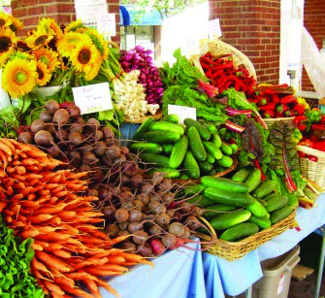
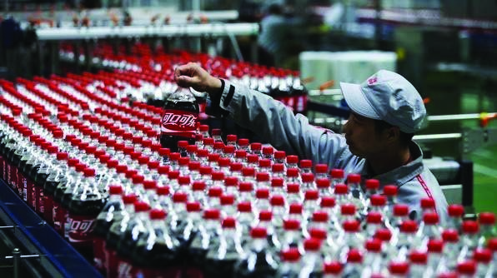
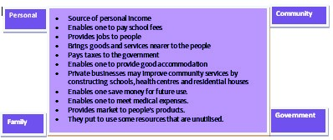
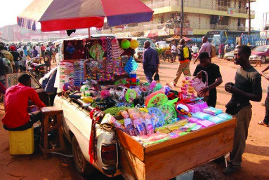
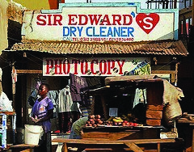

27

Service Businesses

Service businesses provide services to their customers by using talents or skills.

Agro
-
Business

Trade Business

Service Business

Manufacturing

2.1.4
:

Importance of
Doing Business
Many people do business in order to get money to meet
their personal needs. Business also benefits the community and the country as a whole. The following are some
of the
benefits

of doing business:
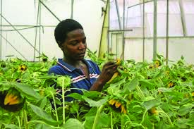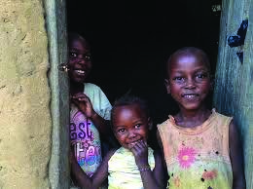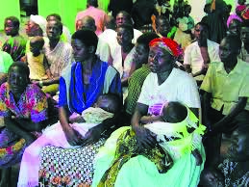

Activity 2.1.3
Using the information above identify the benefits of business
to each category (personal, community, family and
government) and complete the table below in your groups.

The business
owner/personal

Family

The village
members/community

The government

