SENIOR ONE
CHEMISTRY
SELF STUDY MATERIALS
Ministry of Education and Sports SCIENCE PACKAGE

ST JOSEPHS SENIOR SECONDARY SCHOOL NAGGALAMA CHEMISTRY DEPARTMENT

Read through the text below and try out the different tests you should report with the whole work done when the term begins.

Stay safe and avoid Covid.
CHEMISTRY SENIOR ONE
TOPIC ONE: CHEMISTRY AND SOCIETY
Learning Outcomes
After going through the activities in this topic you should be able to;
i) know the appropriate activities to explain the distinct nature of Chemistry.
- Understand why chemistry is studied and how it overlaps with other subjects such as Biology, Physics, Mathematics and Geography.
- understand the importance of
Chemistry and relate knowledge of chemistry to relevant careers.
- Know the contribution of chemistry to the Ugandan economy.
Lesson One: The Nature of Chemistry
INTRODUCTION
In primary seven you learnt about integrated science. I hope you remember what integrated science is.
Here in secondary school, we have science separated into mainly three (3) branches and those are:
- Biology: deals with living things.
- Physics: deals with relationship between energy and matter.
- Chemistry: (you will find out about this in a while)
In this lesson, we shall find out what Chemistry deals with and also the common things we use in everyday life that are made with the knowledge of Chemistry, by carrying out the given activities.
ACTIVITY 1.1
Identify the common things we use in everyday life that you think are made of chemicals. Write your findings in your chemistry note book. ACTIVITY 1.2
INSTRUCTIONS
- Look for the following products/items and assemble them in one place.
▪ Bar soap, Vim, Toilet paper, Jik, Soda, Tooth paste, Pens, Detergent (e.g Omo,sunlight,Nomi),mineral water bottle,a cloth,a comb,shoe polish,a book,Tomato sauce,Blueband
- Observe the products/items critically and answer the given questions, answers should be written in your chemistry note book.
  - Give at least one use of each of the products/ items.
  - Are these products a result of the knowledge of Chemistry?
  - Name any other products produced using the knowledge of Chemistry.
CONCLUSION
Chemistry is all around us. The common chemicals in pharmaceuticals, cosmetics, plastics, foods&beverages, soaps&detergents, water treatment, alcohol preparation at home, are all related to Chemistry.
Question
What careers require the study and knowledge of Chemistry? Write the solutions in your chemistry note book.
Lesson Two: The Meaning of Chemistry
Introduction
Chemistry deals with the study of materials that make up our world. Carry out the following activities to explore the meaning of chemistry further. Activity 2.1.
Steps
1.Burn a piece of paper using a lighted match stick. Observe and write the changes that happen to the paper during the burning.
2.Now consider the following processes that take place in everyday life; i)the rusting of a panga ii)the boiling of water
iii)the rotting of fruits
a)What changes take place in each of the given processes above(i-iii)?
b)What are the necessary conditions for each of the above changes to take place?
3.Name any other processes in which materials change from one form to another? Conclusion
The changes you have just observed and many others show what the study of chemistry is about.
Therefore, Chemistry is the study of matter and the changes that occur to substances under different conditions.
Lesson Three: Why Is Chemistry Studied And How It Overlaps With Other Subjects?
Chemistry helps us to;
- Understand what different materials/ substances are made of and their properties, some are poisonous,
corrosive, toxic, etc
- Know the effects of chemicals to the environment hence we learn how to conserve and protect our environment.
- Get knowledge to advance in science and technology for better and quality human life.
- Acquire knowledge relevant in making new materials which are relevant and useful in our everyday life e.g making of food supplements, distillation of crude oil, making of plastics, making of cosmetics, making of dental creams, manufacture of soap&detergents, making of insecticides&herbicides, etc
- Get knowledge and skills of how to extract and use materials from the
earth e.g Gold, Copper,etc

ACTIVITY 3.1
Using relevant Chemistry text books and the internet, research about more reasons why Chemistry should be studied and how Chemistry relates with other subjects. Write your findings in your Chemistry note book.
Lesson Four: Importance of Chemistry in Everyday Life.
There are many examples of chemistry in everyday life which show how prevalent and important chemistry is.
Activity 4.1
Complete the following statements by filling in the blank spaces
- Digestion relies on chemical reactions between …………. and enzymes to breakdown large substances into ……………… that the body can ………….
- Soaps and ………. are chemical substances that “dissolve”
…………when we wash our clothes, ………. and …………
- Drugs work because of chemistry and its chemistry knowledge helps us know which drugs are …………. or harmful to us as humans.
- Cooking is a chemical change that alters food to make it ……………..,kills dangerous
………… and makes food more
…………
ACTIVITY 4.1 Summarise the mentioned examples in your chemistry note book. Use the internet and research for more ways how chemistry is important in everyday life, write your findings in your chemistry note book.
Lesson Five: Contribution of Chemistry to The Economy of Uganda.
ACTIVITY 5.1
Using the knowledge of common industrial products in our country and their uses, ask older people around you, use books/magazines/newspapers and also the internet, to research about how chemistry contributes to the economy of Uganda. Base your research in the fields of medicine, industries, transport and Agriculture. Write a short report in your chemistry note book, showing the areas in chemistry which contribute to the economy of Uganda.
Lesson six: Laboratory rules and risk assessment Introduction:
At home there is a place where you prepare meals from. Although this place is worthy visiting, it can expose you to danger. The breakable equipment in this place further make it necessary to have guidelines in regard to its access.
Just like there are guidelines followed in almost all the places at home, similarly a science laboratory has guidelines set up to ensure safety.
It is important for you to make safety evaluation of the environment we live in. The evaluation of likely dangers in our environment is called risk assessment. Have you realised that when the floor is wet you reduce speed?
Why?
By the end of this lesson, you should able to;
- Know laboratory rules and regulations
- Understand the importance of risk assessment in order to work safely
Activity 6.1: Understanding laboratory rules and risk assessment
Materials you need:
  - Chart/paper or note book and marker/pen
  - Picture of learners in a laboratory Procedure:
Step 1: Study the picture below that show’s unsafe behaviour of learners in a chemistry laboratory.
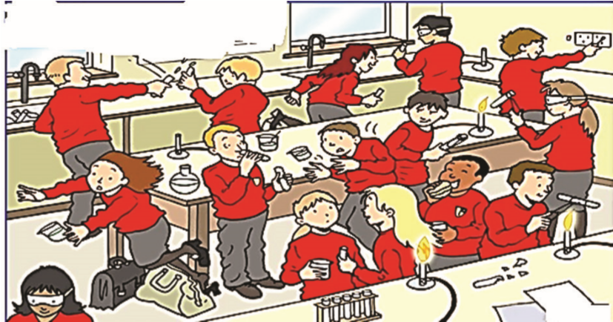

    - Identify and write the risks likely to happen in this laboratory.
    - If any of the dangers identified in a) above happened, write down what you would do.
    - If you were in charge of this laboratory,
write down 5 rules you would setup.
Summary
- In this exercise, you have assessed risks in the picture. Do you realise it is important for you make risk assessment in order to work safely?
- When risks assessment is done and corrective action taken, then the likely danger(s) is/are avoided.
Follow-up activity:
- Visit a kitchen or a general store or garden at home. Observe and identify areas which can be of risk.
- Write 3 dangers that are likely to happen if you accessed the place without taking precaution.
- As a responsible person, which measures or rules can you put in place to safe guard other family members at home?

Lesson seven: Scientific method of investigation Introduction:
The scientific method of investigation enables you increase on your skills in the field of chemistry research. It involves a systematic method of investigation to study and understand events in a natural world. This systematic approach to investigation ensures relevance of risk assessment to yourself and others. Mixtures are common substances we handle in life, separating them is an easy task when we use a scientific method of investigation.
By the end of this lesson, you should able to understand the scientific method to carryout investigations Materials you need:
A detergent e.g Omo, Nomi, etc.
- Tea spoon
- 3 equal glasses
- Hot water
- Water at room
- Temperature.
- Warm water

Investigation question: Does temperature affect formation of bubbles by detergents?
Prediction: The higher the temperature of water the more bubbles formed.
Procedure:
- Measure equal amount of water at different temperature into 3 separate glass glasses,
- To each glass, add a spoonful of detergent and agitate gently for 15 seconds,
- Measure and record the height (in millimetres) of bubbles formed in each glass.
Observations and conclusion:
Table
Glass | Glass with hot water | Glass with warm water | Glass with water at room temperature
Height of bubbles recorded(mm)
- Plot a bar graph to represent information in table above.
- Draw a conclusion to summarise the relationship between amount of bubbles formed and temperature of water.
- Prepare a report on this investigation and how it can help you at home?

Summary:
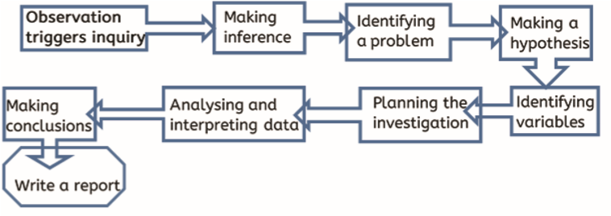
Follow –up activity:
- Using the scientific method of investigation, investigate why rainwater or boiled water readily forms bubbles with soap than any other locally available water.
- What are the possible risks in your investigation
- How is the knowledge of risk important to you and others?
Lesson Eight: States and Changes of States of Matter By the end of this lesson, you should be able to:
- appreciate that matter is anything which occupies space and has mass and can exist in a solid, liquid, gas and plasma form
- understand that solids, liquids and gases have different properties including shape, pouring and compressing
Materials you will need
  - ice water
  - saucepan or tea kettle o source of heat o notebook
Introduction
You probably know already that a substance may be in the form of a solid, a liquid or a gas. These are the three states of matter. With your prior knowledge of states of matter, predict in what state a flame is? Everyone knows that water has a solid state, which is ice, a liquid state, which is water, and a gaseous stage, which is water vapour. In this lesson you will learn about what happens to the different states of matter when subjected to certain conditions.
Procedure
In this activity you will differentiate between a gas, a solid and a liquid
Activity 8.1. Identifying the different states of matter
Step 1: Sketch the arrangement of molecules in solids, liquids and gases i.e. draw three rectangles and label them solid, liquid and gas respectively. Draw circles within each of the rectangles to represent the arrangement of molecules). (Compare your sketches with those in a textbook you can access).
Step 2: Look at the diagram below and give responses to the questions that follow.
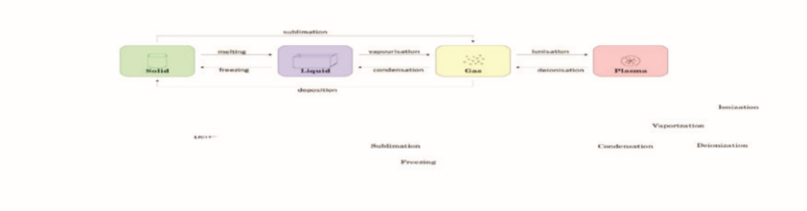
- How many states of matter can you identify? Name the states.
- Which of the states do you think occur naturally on Earth and which one(s) does not?
- Give at least three examples of the states of matter which occur naturally on Earth and two which does not occur naturally.
Activity 8.2. Finding out how states of matter can undergo a change
Step 1: What do you think causes matter to change from one state to another? A change in state of matter means a change in structure and properties of matter.
You will use water in this activity.
Step 2: Obtain ice cubes and liquid water.
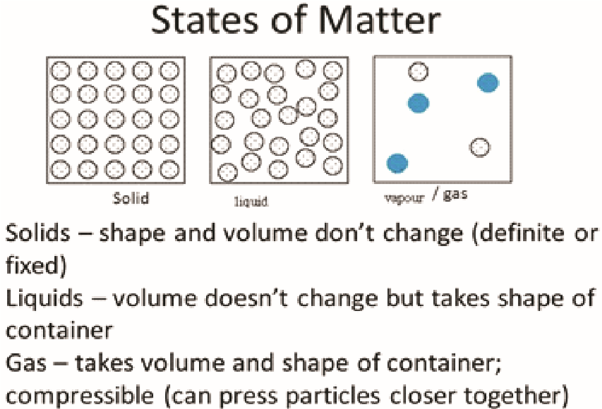
  - Place some ice cubes in a glass. What have
you noticed about the space they occupy and their shape relative to the glass in which they are placed? You might have observed that the shape of the ice did not change with the container it is placed in. Why? This is because it is a solid and has a definite volume and definite shape.
  - Measure half a glass of water. Pour the same
amount of water in different size of containers. What did you observe? You might have observed that liquid water has a definite volume but not a definite shape.
  - the water vapour is all around us, but is invisible! You might have observed that water in its gas state has no definite volume and no definite shape.
Step 3: Is it possible for matter to change from one state of matter to another? If so, when does matter change from one state to another? Matter can change states through heating or cooling, and it is sure to change states when it reaches its boiling point or freezing point. The change can be represented on a graph called heating and cooling curve for water at a constant rate.
Look at the graph of temperature against time, and describe how these states can change.
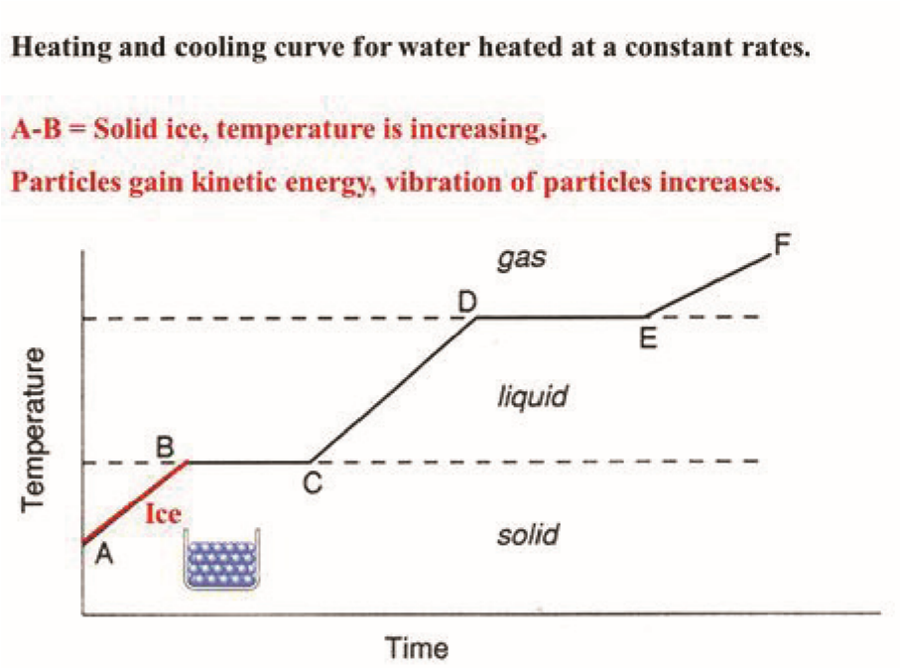
i) A – B shows solid ice. Predict what is happening to the temperature, energy of particles and movement of the particles? ii) What happens between B-C? iii) What happens between C-D?
- D-E shows liquid water. Predict what is happening at this stage.
- What is happening between E-F?
Step 4: How to explain the particle arrangement in states of matter.
The kinetic theory of matter helps us to explain why matter exists in different states (i.e. solid, liquid and gas), and how matter can change from one state to the next. The kinetic theory of matter also helps us to understand other properties of matter.
Therefore, it helps to explain particle arrangement, interparticle forces, movement of particles and the properties of solids, liquids and gases.
Follow-up activity
- In which state of matter are molecules moving slowest?
- What causes a solid to change to a liquid?
- What point has water reached when it turns from a liquid to a solid?
- What occurs when liquid turns into a gas?
- In which state of matter are molecules moving the fastest?
- What effect does the speed of molecules have on matter?
- What happens when water reaches its boiling point?

Test one

1. Explain how the study of chemistry will help you in your future career?
2. Do you think the study of chemistry is important, in the preservation of the environment?
3. In what ways might chemistry be useful to a farmer in your area?
Below are the questions about the importance of chemistry.
(a) State three ways in which chemical and pharmaceutical industries have made people’s lives easier and better.
(b)Patience is an ability that can be learned, state ways in which chemistry teaches you to be patient.
4. List four main industrial products that are made in Uganda and their contribution to the domestic life.
5Both rural and urban women use chemistry based products in their daily life. Who uses more than the other and why.
(b) Make a list of products of rural and urban women
5. Make a summary of the importance of chemistry to the economy of Uganda.

Test two.
1a) Why is chemistry a laboratory science?
- Suggest four examples of chemistry in our daily life.
- Why is chemistry important in our everyday life.
2. “Chemistry plays a vital role in feeding the growing world population and contributes greatly to the Ugandan economy.” Identify the areas in chemistry which contribute to the economy of Uganda.
3a) “Burn a piece of paper using a candle or a lighted match stick.” What changes take place to the paper during the burning?
b) Name any other processes in which materials change from one form to another.
4.Prepare a glass of juice using a mango fruit.
i)State the aim of the activity.
ii)List the materials required for the activity.
iii)Identify the steps followed in making the juice. iv) What safety measures were required to prepare safe juice.

Test three
TERM 1 2020 RECESS ACTIVITIES
S.1 CHEMISTRY

1. Figure 1 below shows a mother boiling water in a saucepan, use it to answer the
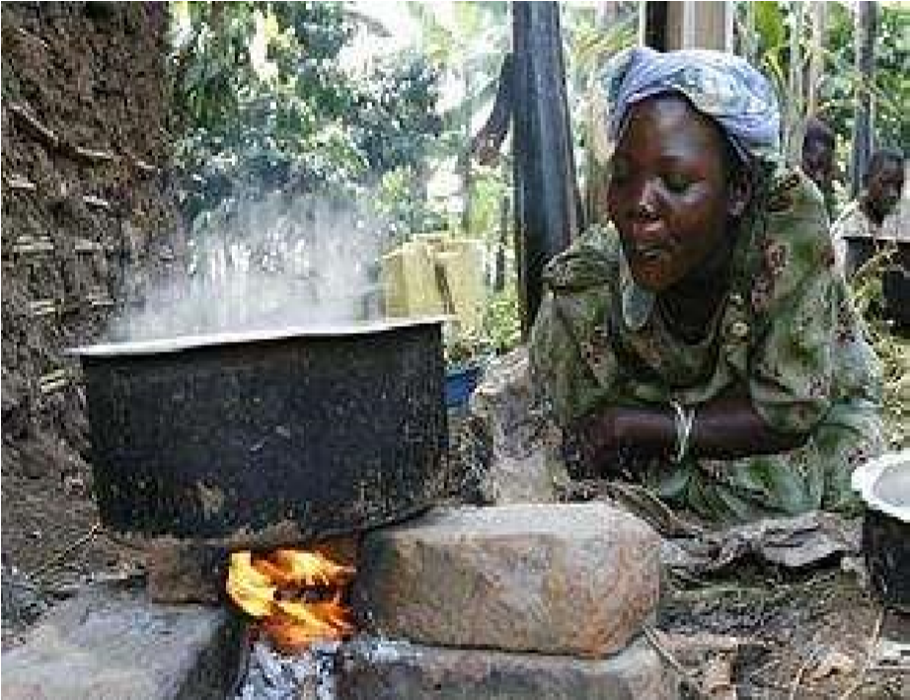
q
ue
sti
on
s
b
e
lo
w
:

a
)

I
de
n
t
i
f
y

t
h
e

s
t
a
t
e
s

o
f

m
a
t
te
r
i
n

t
h
e
p
ict
u
r
e
.

.
.
.
.
.
.
.
.
.
.
.
.
.
.
.
.
.
.
.
.
.
.
.
.
.
.
.
.
.
.
.
.
.
.
.
.
.
.
.
.
.
.
.
.
.
.
.
.
.
.
.
.
.
.
.
.
.

…………………………………………

…………………………………………

…………………………………………

b
)

How

doe
s

f
i
r
e
/
h
ea
t

c
a
u
se

c
h
a
n
g
e
s
in

st
a
t
e
s
o
f

m
a
t
te
r
?

…………………………………………

F
i
gu
re

1
:

………………………………………
…
……………………………………………………

………………………………………………………………………………………………

…………………………………………
…………
…………………………………………

………………………………………………………………………………………………
………………………………………………………………………………………………
- How is the knowledge of chemistry being applied to benefit man?
………………………………………………………………………………………………
………………………………………………………………………………………………

- How are chemistry processes negatively affecting the mother?
………………………………………………………………………………………………
………………………………………………………………………………………………
………………………………………………………………………………………………
- Do you think after studying chemistry you can improve the livelihood of this mother? Suggest 2 things you can do.

……………………………………………………………………………………………… ………………………………………………………………………………………………
……………………………………………………………………………………………… ……………………………………………………………………………………………...
2. Chemistry can be applied everywhere, a senior one student came up areas where chemistry is applied and matched them into the term ‘chemistry’ as shown in figure 2.
a) Do you agree with this student’s idea? Explain your answer.
…………………………………………………...
…………………………………………………...
…………………………………………………...
…………………………………………………... …………………………………………………...
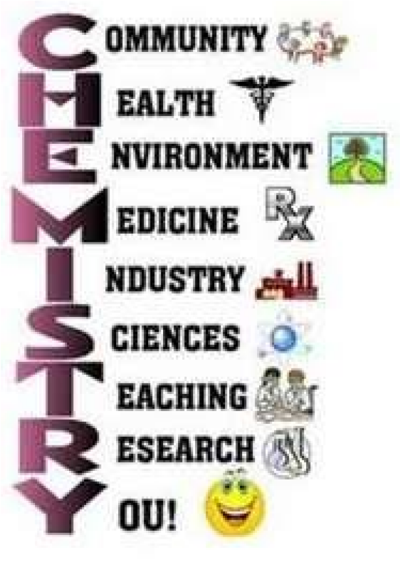
………………………………………………………………………………………… ………………………………………………………………………………………… …………………………………………………………………………………………

F
i
gu
re
2
:

………………………………………………………………………………………….
………………………………………………………………………………………… ………………………………………………………………………………………… ………………………………………………………………………………………… …………………………………………………………………………………………
………………………………………………………………………………………… …………………………………………………………………………………………
…………………………………………………………………………………………

………………………………………………………………………………………… ………………………………………………………………………………………… …………………………………………………………………………………………
………………………………………………………………………………………… …………………………………………………………………………………………
…………………………………………………………………………………………

…………………………………………………………………………………………
………………………………………………………………………………………… …………………………………………………………………………………………
3. Figure 3 below shows unsafe behaviour from learners in a chemistry laboratory. Study it and answer the questions that follow.
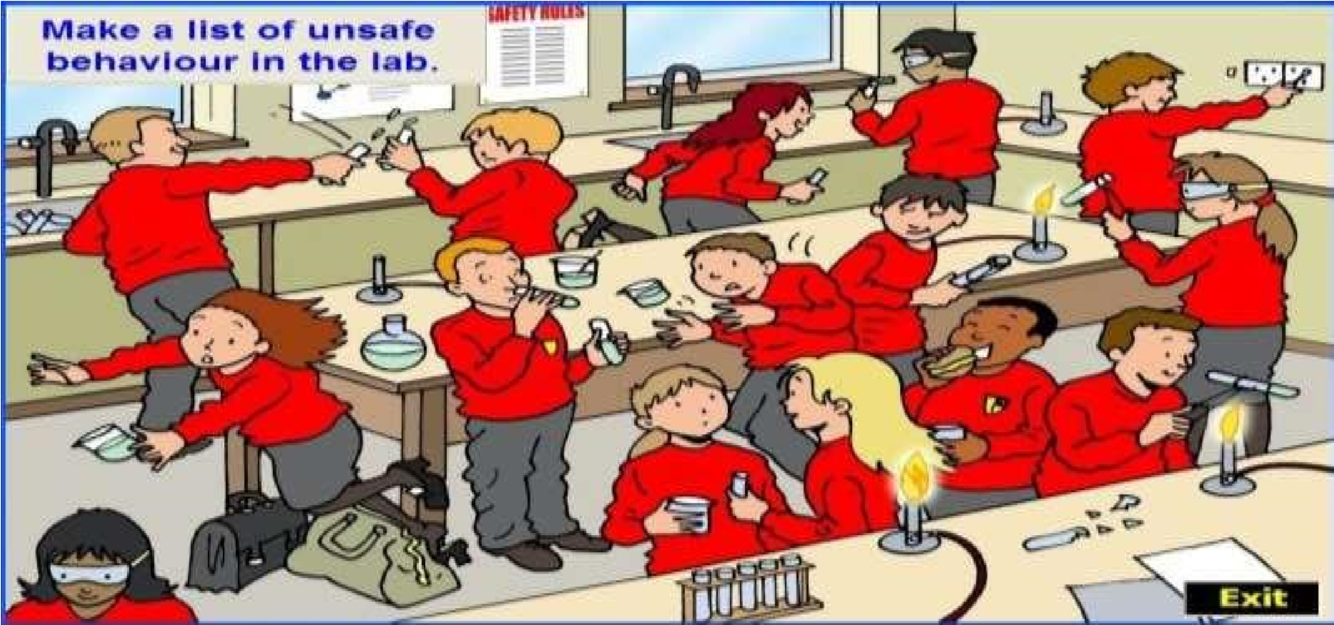

- Which forms of unsafe behaviour can you identify?
………………………………………………………………………………… ………………………………………………………………………………… ………………………………………………………………………………… …………………………………………………………………………………
…………………………………………………………………………………
- Did any of the learners take precaution while in the laboratory? What
did he/she do?

………………………………………………………………………………… ………………………………………………………………………………… …………………………………………………………………………………

- Which laboratory rules were violated by learners?
………………………………………………………………………………… ………………………………………………………………………………… ………………………………………………………………………………… …………………………………………………………………………………
…………………………………………………………………………………
- If you were the chemistry teacher, what would you do to these learners?
…………………………………………………………………………………

………………………………………………………………………………… …………………………………………………………………………………

